
INDUSTRY REPORT
Management Consultants in the UK
Dec 2025

About

IBISWorld
IBISWorld specializes in industry research with coverage on thousands of global industries. Our comprehensive data and in-depth analysis help businesses of all types gain quick and actionable insights on industries around the world. Busy professionals can spend less time researching and preparing for meetings, and more time focused on making strategic business decisions.

Table Of Contents | Standard

1. About 4
Codes 4
Definition 4
Related Terms 4
What's Included 4
Companies 5
Related Industries 5
Additional Resources 6
2. At a Glance 7
Key Takeaways 7
Products and Services 8
Major Players 9
Key External Drivers 10
Industry Structure 10
SWOT 11
Executive Summary 11
3. Performance 13
Highlights 13
Key Takeaways 13
Performance Snapshot 14
Outlook 24
Life Cycle 27
4. Products and Markets 28
Key Takeaways 28
Products and Services 29
Major Markets 34
International Trade 37
5. Geographic Breakdown 38
Key Takeaways 38
Business Locations 39
6. Competitive Forces 42
Key Takeaways 42
Concentration 42
Barriers to Entry 44
Substitutes 45
Buyer & Supplier Power 47
7. Companies 49
Key Takeaways 49
Market Share 50
Companies 51
8. External Environment 60
Key Takeaways 60
External Drivers 60
Regulation & Policy 64
Assistance 65
9. Financial Benchmarks 66
Key Takeaways 66
Cost Structure 66
Financial Ratios 71
Valuation Multiples 74
Key Ratios 75
10. Key Statistics 76
Industry Data 76

1. About
https://my.ibisworld.com/uk/en/industry/M70.229/about

Codes
UK-SIC 2007 | 70.22/9

Definition
Management consultants provide advice, guidance and operational assistance to businesses and other organisations on management issues. Principal areas of consultation include corporate strategic and organisational planning, marketing, human resources and operational management. The industry excludes the provision of consulting advice on legal, engineering and educational matters. Consulting relating to financial management is also excluded.

Related Terms

AUDITING
Reviewing a company's financial operations to ensure regulatory compliance.

CORPORATE STRATEGY
The formulation and implementation of the major initiatives taken by a company's top management on behalf of the owners.

OMNICHANNEL SELLING
An approach to sales where customers can buy a firm's goods in multiple ways, such as by telephone, online or in a store. These channels are interconnected to provide a seamless shopping experience.

BIG FOUR
The nickname used to refer to the four largest professional services networks in the world: PricewaterhouseCoopers, Deloitte, KPMG and Ernst & Young.

RESTRUCTURING
Modifications to a business that can provide improvements to cash flow, profit and the corporate balance sheet.

What's Included
- IT strategy
- Corporate strategy
- Process and operations management
- Programme or project management
- Risk management
- Human capital
- Economic and regulatory consulting
- Business transformation consulting
- Customer and marketing strategy
- Environmental consulting

Companies
- Accenture (UK) Ltd
- PricewaterhouseCoopers LLP
- The Boston Consulting Group UK LLP
- McKinsey & Company Inc United Kingdom
- Deloitte LLP
- KPMG LLP
- Ernst & Young LLP

Related Industries

Industries in the Same Sector
- Competitors:
  - Procurement Outsourcing Services in the UK
- Complementors:
  - Legal Activities in the UK
  - Financial Management in the UK
  - Consultant Engineering Services in the UK
  - Employment Placement Agencies in the UK

International Industries
- Global Management Consultants
- Management Consulting in the US
- HR Consulting in the US
- Expert Networks in the US
- Occupational Health & Workplace Safety Services in the US
- Healthcare Consultants in the US
- Pharmaceutical Contract Management Consulting in the US
- Marketing Consultants in the US
- Group Purchasing Organizations in the US
- Management Consulting in Canada
- HR Consulting in Canada
- Management Consulting in Australia
- Consulting Services in New Zealand
- Management Consultants in Ireland
- Management Consulting in China

Additional Resources
- Institute of Consulting
- Management Consultancies Association
- Consultancy.uk

2. At a Glance
https://my.ibisworld.com/uk/en/industry/M70.229/at-a-glance
Revenue  £82.0bn  ’21-’26 ↑ 2.0 %  ’26-’31 ↑ 4.3 % | Employees  476k  ’21-’26 ↑ 2.5 %  ’26-’31 ↑ 3.0 % | Businesses  184k  ’21-’26 ↑ 3.1 %  ’26-’31 ↑ 3.5 %
Profit  £15.5bn  ’21-’26 ↑ 3.3 % | Profit Margin  18.9%  ’21-’26 ↑ 1.2 pp | Wages  £25.5bn  ’21-’26 ↑ 3.6 %  ’26-’31 ↑ 3.8 %

Key Takeaways

Performance
- Challenging economic conditions dampen revenue growth. Management consultants’ revenue growth has slowed down amid a challenging economic climate, including geopolitical uncertainty and trade tensions, which are squeezing business spending and limiting deal-making activity.
- Demand for IT strategy consulting services is climbing. Consulting services related to IT strategy, including digital transformation and AI, are driving growth in due to the ongoing prevalence of digital technology in business.

Products and Markets
- Risk management services receive a boost. Many businesses have turned to risk management consultants to help navigate and limit possible risks from Brexit, COVID-19 and inflationary pressures. Geopolitical tensions and escalating trade wars have further supported demand for risk management solutions.
- Tech and IT solutions have advanced. The digital transformation has encouraged the development of new and complementary consulting methods, bringing in new potential revenue streams.

Products and Services
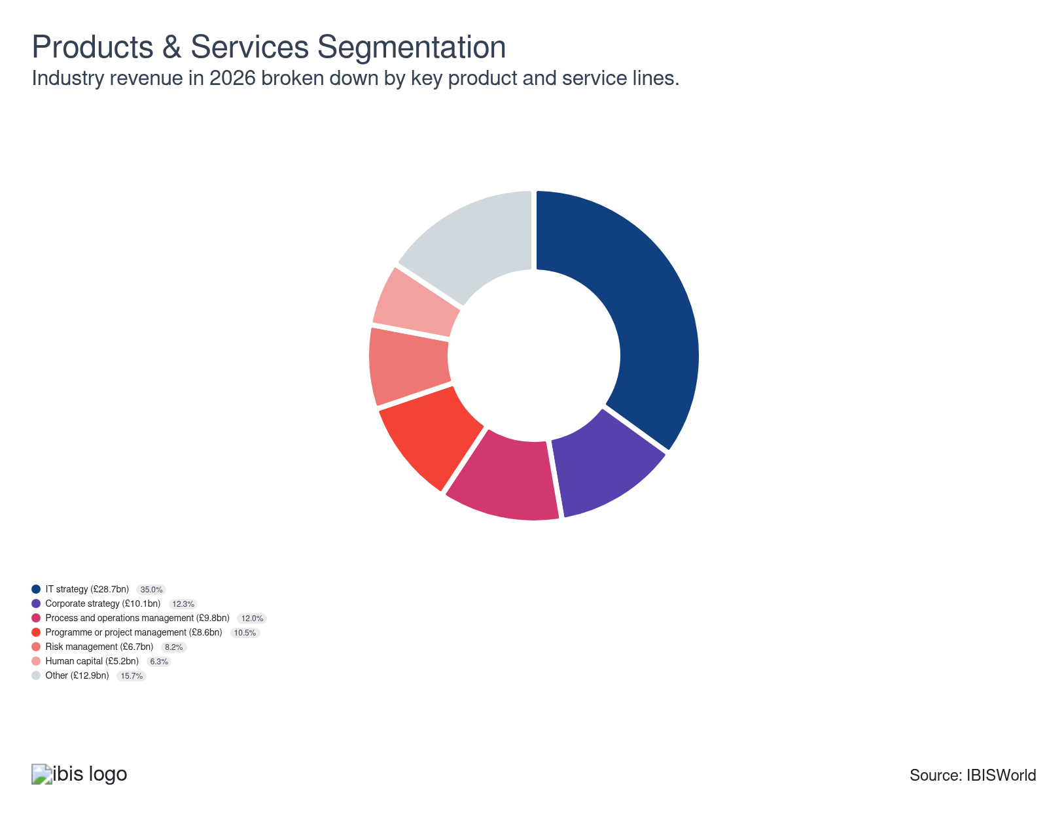

Major Players
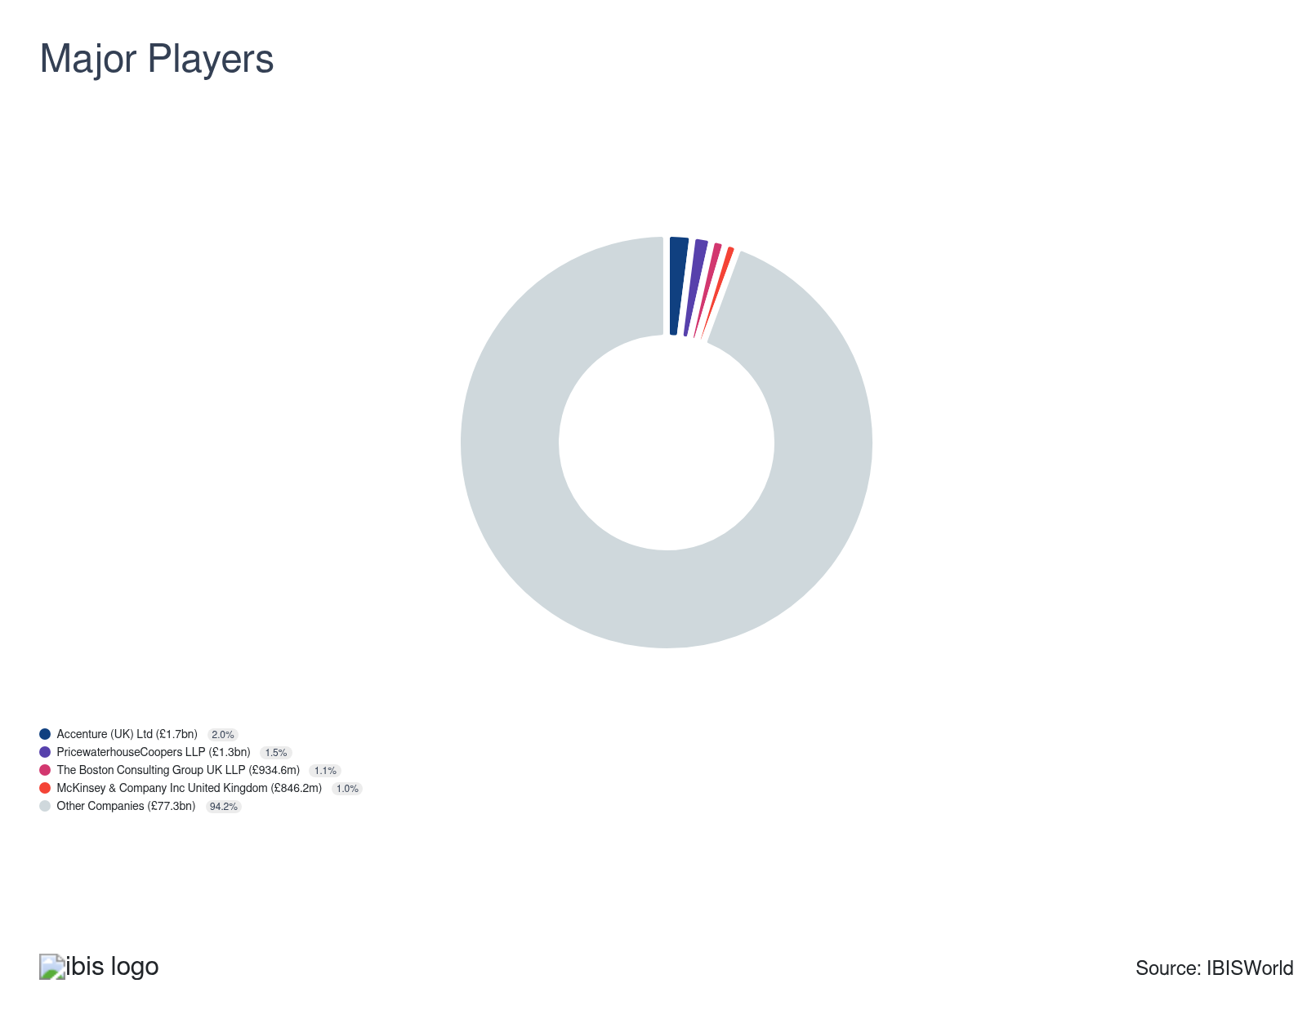

Key External Drivers
Key External Drivers | Impact
Business confidence index | Positive
Government capital expenditure | Positive
Mergers and acquisitions involving UK companies | Positive
Number of businesses | Positive
Demand from banks | Positive
IT and telecommunications adoption | Positive

Industry Structure
Characteristic | Level | Trend
Concentration | Low
Barriers To Entry | Low | Steady
Regulation and Policy | Low | Increasing
Life Cycle | Growth
Revenue Volatility | Moderate
Assistance | Low | Steady
Competition | Moderate | Increasing
Innovation | High

SWOT
Strengths  Growth Life Cycle Stage  Low Imports  High Profit vs. Sector Average  Low Customer Class Concentration  Low Product/Service Concentration  High Revenue per Employee  Low Capital Requirements | Weaknesses  Low & Steady Barriers to Entry  Low & Steady Level of Assistance | Opportunities  High Revenue Growth (2021-2026)  High Revenue Growth (2026-2031) | Threats  Low Performance Drivers  Government capital expenditure

Executive Summary

Digital transformation: Soaring demand for IT strategy consulting fuels revenue growth as businesses seek expert advice on tech integration
In recent years, while adverse economic conditions have slowed down demand for management consultants, revenue has been upheld by swelling demand for IT consulting services. While expanding business activity and spending have fuelled management consultants’ revenue during upbeat economic conditions, the provision of countercyclical services has supported revenue during periods of economic instability. They’ve also benefitted from regulatory changes, as businesses have required help to fine-tune their strategies and operations following Brexit and recent volatile conditions, including the COVID-19 pandemic, severe inflationary pressures and geopolitical tensions. Revenue is expected to climb at a compound annual rate of 2% over the five years through 2025-26 to £82 billion, despite a 0.3% dip in the current year.
Currently, the industry’s most promising revenue streams lie in IT consulting services, including digital transformation, AI, data, cloud services and cybersecurity. The rapid adoption of tools like big data and cloud computing has pushed many businesses to seek consulting expertise, not just to stay competitive but to navigate the risks associated with such changes. However, these growth pockets have emerged against a backdrop of economic headwinds. Stubbornly high inflation, elevated borrowing costs and subdued business confidence have led to cautious spending on consultancy services, especially in areas like strategy and transactions. Major consultancies like EY and Deloitte have reported softer growth and even contractions, prompting many to tighten hiring and trim staff in response to weaker demand. Meanwhile, despite competitive pressures, cost-cutting initiatives and booming demand for specialised consulting services commanding premium fees like digital transformation, environmental consulting and risk management have supported profit growth.
Revenue is forecast to swell at a compound annual rate of 4.3% over the five years through 2030-31 to £101.2 billion. Digital transformation will continue to fuel revenue growth as businesses invest significant sums to integrate advanced technology into their operations. As such, firms will also look to bolster their expertise in this area. Evolving regulations in various markets, like financial services and data protection, will necessitate the expert guidance of consultants. Demand for consultancy regarding sustainability will also aid revenue growth, with clients pursuing ESG goals. However, potential cuts to government spending on external consultants could limit demand, pushing management consultants to search for growth opportunities elsewhere. As the business environment evolves, consultancies that can adapt to shifting market demands and offer innovative, tailored services will likely thrive. Profitability will remain under pressure due to intense competition.

3. Performance
https://my.ibisworld.com/uk/en/industry/M70.229/performance

Highlights
Revenue  £82.0bn  2021-26 CAGR ↑ 2.0 %  2026-31 CAGR ↑ 4.3 % | Employees  476k  2021-26 CAGR ↑ 2.5 %  2026-31 CAGR ↑ 3.0 % | Businesses  184k  2021-26 CAGR ↑ 3.1 %  2026-31 CAGR ↑ 3.5 %
Profit  £15.5bn  2021-26 CAGR ↑ 3.3 % | Profit Margin  18.9%  2021-26 CAGR ↑ 1.2 pp

Key Takeaways
- Challenging economic conditions dampen revenue growth. Management consultants’ revenue growth has slowed down amid a challenging economic climate, including geopolitical uncertainty and trade tensions, which are squeezing business spending and limiting deal-making activity.
- Demand for IT strategy consulting services is climbing. Consulting services related to IT strategy, including digital transformation and AI, are driving growth in due to the ongoing prevalence of digital technology in business.

Performance Snapshot
Revenue: | ↑ 2021-26 Revenue CAGR +2.0%
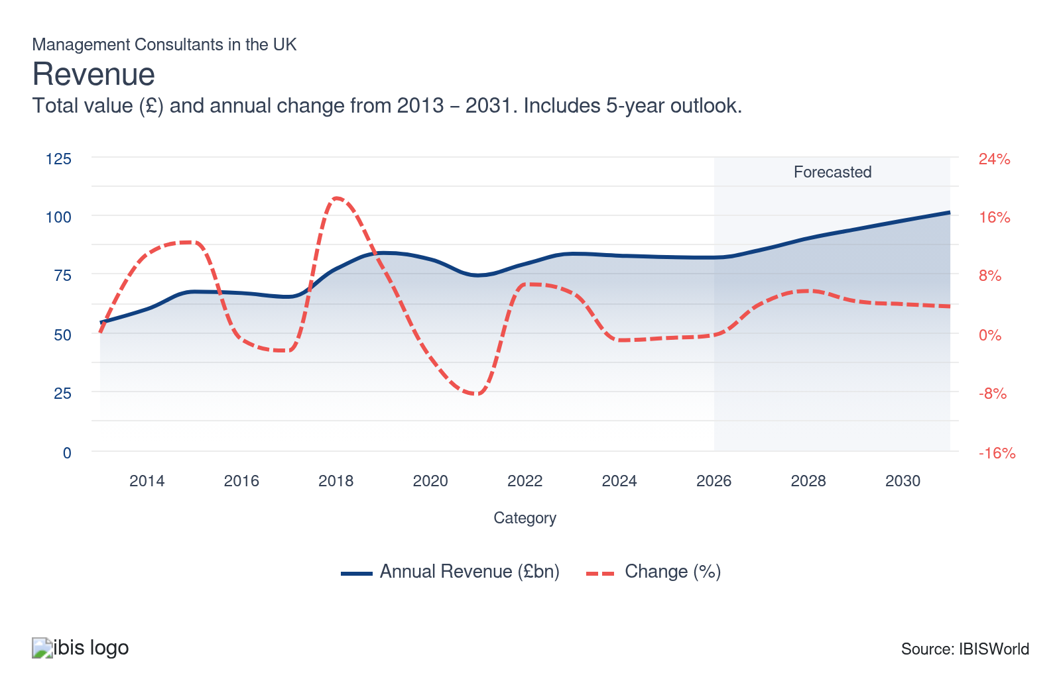
Employees: | ↑ 2021-26 Employees CAGR +2.5%
Employees  476k  ’21-’26 ↑ 2.5 %  ’26-’31 ↑ 3.0 % | Employees per Business  3  ’21-’26 ↓ 0.5 %  ’26-’31 ↓ 0.5 % | Revenue per Employee  £172k  ’21-’26 ↓ 0.5 %  ’26-’31 ↑ 1.3 %
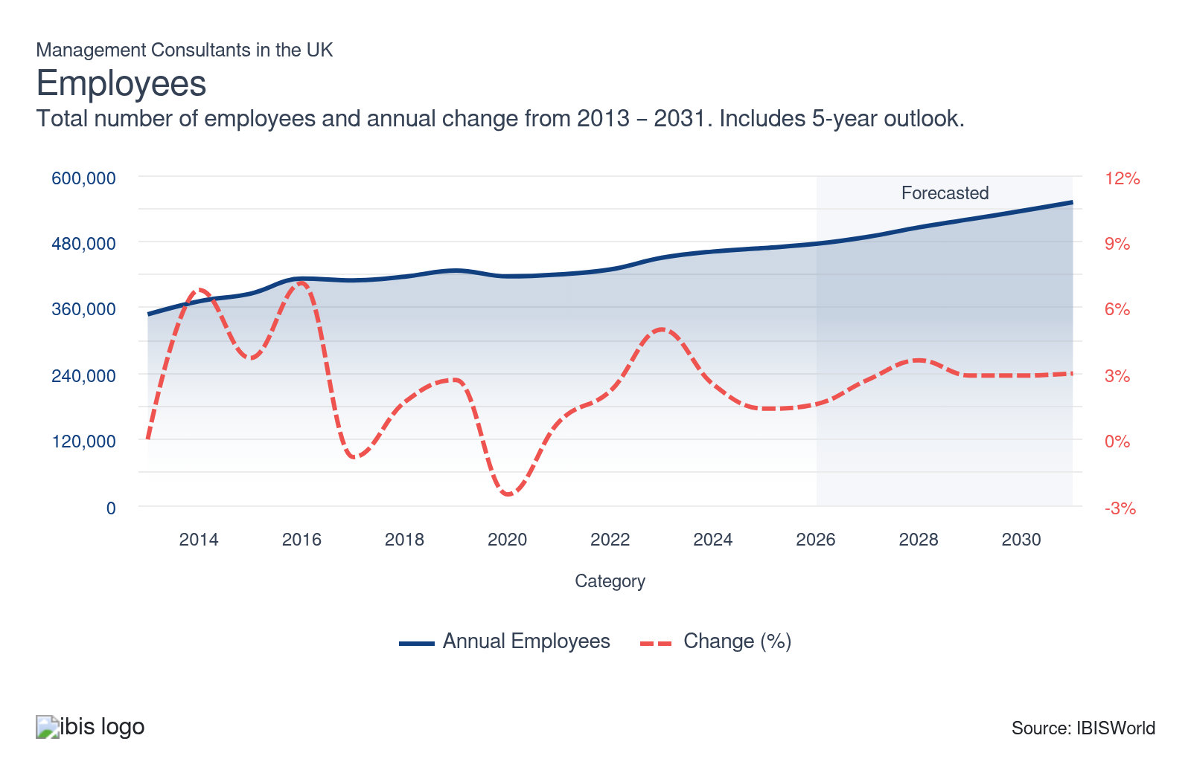
Businesses: | ↑ 2021-26 Business CAGR +3.1%
Businesses  184k  ’21-’26 ↑ 3.1 %  ’26-’31 ↑ 3.5 % | Employees per Business  3  ’21-’26 ↓ 0.5 %  ’26-’31 ↓ 0.5 % | Revenue per Business  £445.5k  ’21-’26 ↓ 1.1 %  ’26-’31 ↑ 0.8 %
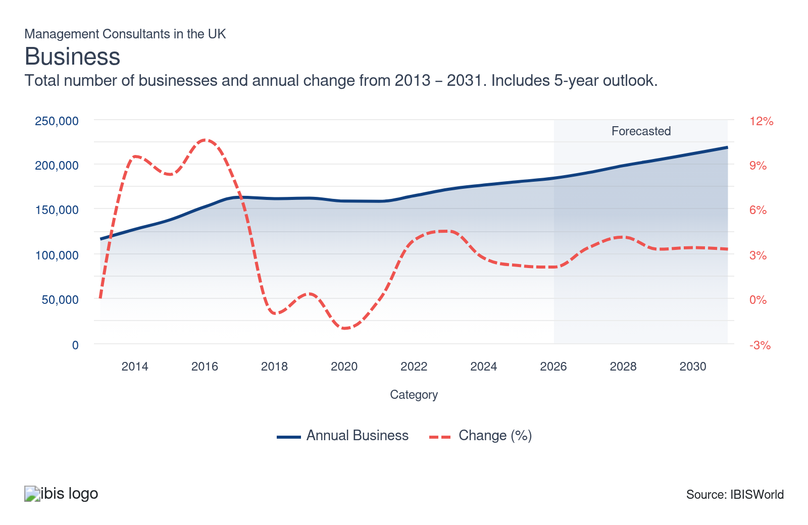
Profit: | ↑ 2021-26 Profit CAGR +3.3%
Total Profit  £15.5bn  ’21-’26 ↑ 3.3 % | Profit Margin  18.9%  ’21-’26 ↑ 1.2 pp | Profit per Business  £84,197
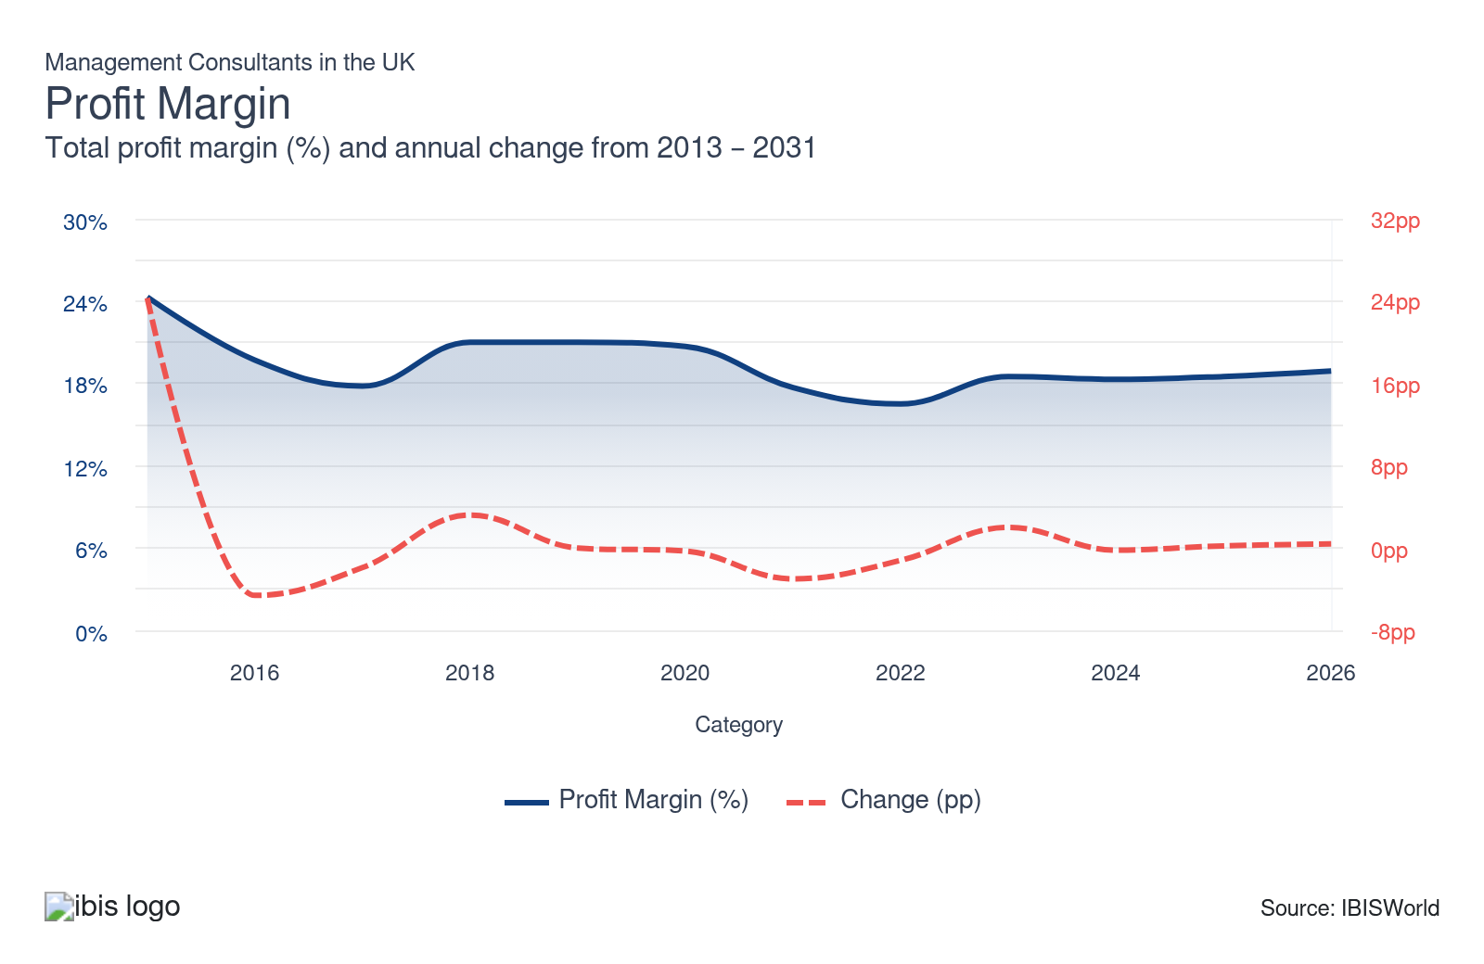
Current Performance
Current Performance

What's driving current industry performance?

The digital transformation creates a promising new revenue stream
- The ongoing integration of digital technology in business has driven demand for IT strategy consulting. Companies have sought advice on data management and the use of IT to keep up with competitors.
- Businesses are also racing to adopt emerging technologies like AI, big data and cloud computing, creating significant revenue opportunities for consultants. Demand for strategic guidance on cybersecurity is also providing substantial opportunities, with businesses seeking to protect sensitive data amid the growing threat of cyber-attacks. According to the government's Cyber Security Breaches Survey 2025, 43% of businesses reported having experienced some form of cyber security breach or attack in the last 12 months, with an estimated 8.58 million cyber crimes hitting UK businesses, up from 7.78 million cyber crimes in the previous year.
- Consultancies specialising in providing IT strategy for businesses have grown the most over the past five years, as companies have sought advice to transition to remote working and adapt to post-pandemic operating dynamics. Demand has been exacerbated by the recent boom in AI tools and businesses’ soaring desire to integrate such advanced technology into their operations. For instance, for The Financial Times in February 2025, the chief executive of Boston Consulting Group (BCG), Christoph Schweizer, stated that “BCG’s growth will stem from advising on AI projects”, with businesses seeking help with AI, from initial strategy through to implementation.
- Demand for IT strategy services, particularly digital transformation, cybersecurity, data and cloud services, stands as the leading driver of industry growth in 025-26 as digitalisation in the economy continues. To capitalise on these opportunities, consulting firms can expand their IT solutions teams, while larger consultancies can acquire smaller consultancies to grow their expertise and reach. Such is the case with Accenture, known for its substantial acquisition activity, which purchased financial services and digital transformation management consultancy Altus Consulting in March 2025.

Adverse economic conditions slow growth in demand for consultants
- Economic headwinds and geopolitical uncertainty have created challenging conditions since 2023-24, hindering spending on management consultants. Soaring costs – the result of severe inflation and higher borrowing costs – squeezed businesses’ budgets, weakening demand for consultants. EY reported a slowdown in sales growth in the year through June 2024, largely driven by a lacklustre performance in its consulting and strategy and transactions business units amid the challenging economic climate. Similarly, Deloitte’s consulting division reported a 10% contraction in the 12 months through May 2025, as businesses held back on investments and change programmes, leading to the firm’s first dip in revenue in 15 years.
- While inflation has subsided, it remains elevated and above the BoE’s 2% target and has crept upwards in 2025-26. The ONS reports that annual inflation stood at 3.6% in October 2025, up from 2.3% in October 2024. This, combined with prolonged geopolitical tensions and tax concerns among UK businesses, has subdued business confidence and heightened economic uncertainty. The Institute of Chartered Accountants in England and Wales’ national Business Confidence Monitor for Q3 2025 reported a drop in business confidence for the fifth consecutive quarter, squeezing spending on management consulting services and weakening revenue growth in 2025-26.
- However, heightened demand for countercyclical services like risk management and cost reduction initiatives has limited the dip in industry revenue over recent years. The Financial Times reported in February 2025 that, according to the Management Consultancies Association, cost reduction projects “will be the third greatest driver of growth” in the UK (only after AI and digital technology work), highlighting the lingering economic instability and pressures faced by businesses in the current year. Consultants that are agile and offer a variety of tailored services to a range of industries are better positioned to withstand the slowdown in work.

Volatile M&A activity hampers consulting demand
- Following the plunge in M&A activity during the pandemic, the Office of National Statistics reported that the total value of M&A activity involving UK companies increased by 137.6% in 2021-22. In tandem with post-lockdown market recovery, dealmakers pointed to the UK equity market trading at a significant valuation discount relative to global peers – close to a 30-year low – to stimulate a boom in M&A activity.
- According to PwC, the total number of deals and total deal value in 2022 dropped by 16% and 56%, respectively. Economic adversity continued in 2023-24, hindering business activity. PwC reveals that the number of deals in the UK and the total deal value plunged by 17% and 41%, respectively, in 2023, limiting business spending on consultants providing services like corporate strategy, project management and process management.
- According to PwC, UK M&A value expanded by 66% in value to £68 million in H1 2024 compared to H1 2023. However, it reported that UK M&A dropped by 12.3% to £57.3 billion and volumes contracted by over 19% in H1 2025 compared with H1 2024. This has been driven by continued economic uncertainty amid geopolitical tensions, US tariff concerns and implications from the Autumn Budget 2024, which decimated business confidence and activity.
- Given the volatile deals activity market, firms have had to shift focus to services like risk management, digital transformation and environmental consulting, where demand has been more resilient.

Strategic partnerships widen consultants’ target markets
- Larger clients have increasingly requested that management consultancy companies help implement their recommendations, taking on some of the risks and sharing in successes. Part of this process involves a success-fee remuneration basis, with payments staggered over time.
- Strategic alliances have been formed between management consultants, specialist consultancies and software suppliers to broaden the range of services offered to clients. This diversification is important in maintaining a competitive advantage and meeting growing demand for integrated solutions. Accenture has acquired several companies that operate in digital and media services to expand its field expertise.
- Consultants that partner with tech businesses can access innovative tools and platforms to deliver more comprehensive digital transformation solutions. Incorporating AI and data analytics capabilities through such partnerships can help consulting firms deliver valuable, data-driven insights.

A drop in demand forces job cuts, though there are signs of reversal
- Economic uncertainty and a slowdown in business activity have weakened revenue growth since 2022-23, as spending on external consultants has taken a hit.
- Consultancies, primarily larger firms, have taken steps to reduce hiring in line with weaker demand. Overhiring after the COVID-19 outbreak, when deal-making surged, heightened the need to cut staff. Labour market analytics company Vacancysoft reported that job openings at UK consultancies plunged by more than 80% in 2023 amid the economic slowdown and overhiring.
- Big Four firms have all announced plans to cut staff numbers in the UK in recent years. According to CityAM in December 2024, the Big Four firms made over 900 roles redundant over 2024 amid a slowdown in demand. This continued in 2024-25 amid prolonged economic challenges. For example, in December 2024, EY announced plans to cut 150 jobs in its UK consulting division.
- Meanwhile, analysis by the Financial Times states that the number of partner promotions at the Big Four accounting firms dropped to 179 in 2025, from over 200 in 2024 and from a peak of 276 in 2022. Nonetheless, 2025-26 is more promising for consultants, with the Financial Times reporting that stronger demand for advisory services, driven by AI strategies, is encouraging firms to resume hiring. Although hiring is expected to remain below historic levels, there is a soaring demand for talent in areas like data, cybersecurity, risk and cloud services. The significant pay packages commanded by individuals with these skills, combined with the current lack of skilled labour in the UK, pose challenges to consultancy firms.

What influences industry volatility?

Faltering business confidence levels influence demand
- Movements in business confidence contribute to the industry’s volatility. During periods of low business confidence, companies tend to cut back on expenditure and reduce spending on non-essential consulting services.
- Countercyclical consulting services, including restructuring, cost cutting and risk management, aid revenue when confidence is low and economic conditions are poor, providing consulting firms with some revenue stability during these periods. This has helped keep the industry's volatility at a moderate level, while most industries in the sector have seen heightened volatility due to fluctuating economic conditions.
- When economic conditions are strong and business confidence is high, management consulting revenue is driven by demand from companies seeking professional advice to take advantage of a favourable operating environment to maximise efficiency and revenue.
- Digital transformation across the economy has provided a buffer against volatility as demand for IT consulting services has remained resilient even during economic downturns. Businesses seek the specialised expertise of consultants to guide them in implementing technology strategies based on their specific needs. Demand for cybersecurity solutions, AI and cloud integration has been particularly strong, boosting revenue growth.

Government expenditure sways revenue growth
- Following Brexit, business demand for guidance and assistance picked up. The government required management consultants' aid and expertise and outsourced some of the work to them.
- The COVID-19 pandemic raised demand for management consultants from the public sector, as the government heavily relied on their advice regarding lockdown restrictions and vaccine deployment.
- According to Tussell, public-sector spending on management consultants reached £3.4 billion in 2023-24, £1.3 billion (62%) more than pre-pandemic levels in 2019-20. Government department cuts have meant the public sector has sought more external consultant services to cover the shortage of in-house experts. The high level of government spending on external consultants has provided a steady revenue stream for consulting firms.
- In plans set out in July 2024, the government is looking to reduce reliance on private consultants and halve consultancy spending by 2026., weighing on revenue and likely heightening volatility as consultants seek alternative revenue channels.
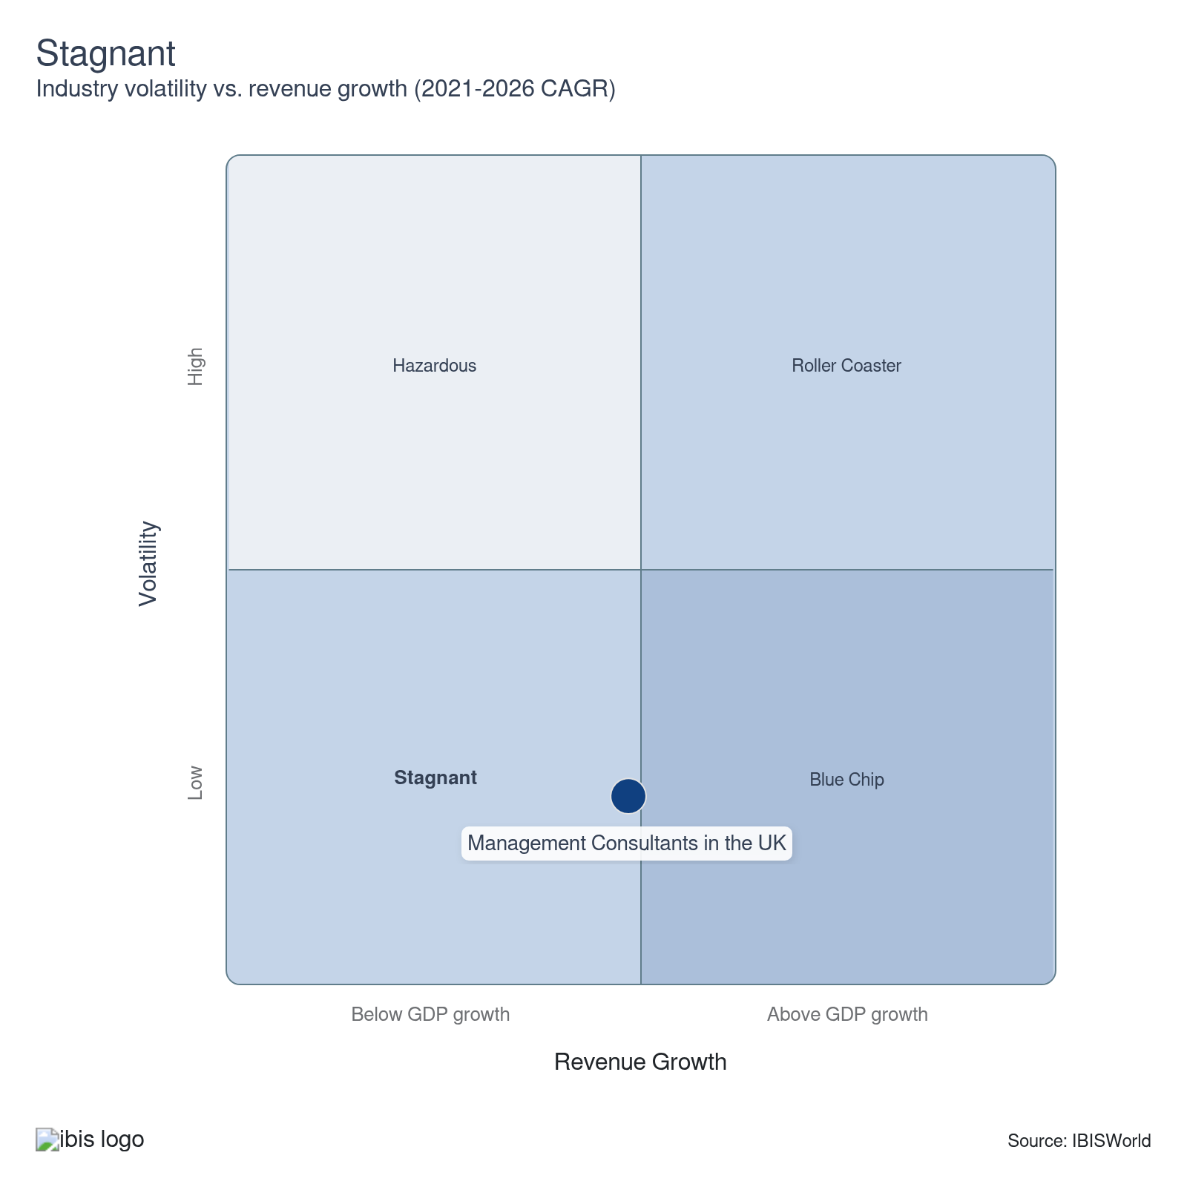

How do successful businesses overcome volatility?
Develop a strong reputation
Success in management consulting hinges on credibility and a good track record. A firm known for providing quality services is more likely to benefit from sustained customer loyalty and increased referrals, ensuring stable revenue regardless of economic fluctuations.
Adapt quickly to changing regulations
Consultancy firms’ ability to traverse through new regulations will protect them against volatility, as clients require consultants to aid them through upcoming changes, like evolving environmental and data privacy laws.
Secure a highly skilled workforce
Management consultancies need highly knowledgeable workers. When a firm possesses talented consultants, it can outperform the competition, attract more clientele and stabilise revenue.
Vary services to suit different needs
Versatility in service offerings, from providing corporate strategy advice to environmental consulting, allows firms to cater to diverse clients. This creates a more diversified income stream that helps maintain consistent revenue even when market conditions are volatile.
Outlook | ↑ 2026-31 Revenue CAGR +4.3%

What's driving the industry outlook?

Improving economic conditions will provide opportunities, but demand from the public sector is under threat
- Economic uncertainty may prevail in the near term, due to continued geopolitical tensions and sustained inflation. The Office for Budget Responsibility anticipates GDP to reach 1.4% in 2026, followed by 1.5% for each subsequent year until 2030. This is a downgrade from previous estimates, resulting in an average GDP growth rate of 1.5% over the next five years, 0.3 percentage points lower than forecast in March 2025. Nonetheless, in the medium term, a stabilising inflation (with the OBR predicting inflation to return to the 2% target in 2027) and cuts to interest rates will boost business optimism and encourage greater business activity and spending on consulting services. Businesses will seek consultants’ expertise to reevaluate their processes and enhance efficiency.
- An expanding economy should boost M&A activity, driving demand for specialised procyclical management consulting services. This will likely encourage more management consultants to target specialisation in this area to benefit from the growing opportunities.
- AccountancyAge’s Top 50+50 Accountancy Firms 2024 survey highlights the shift to advisory services. It found that fees from consultancy services have continued to climb across the top 100, with fee income from consultancy averaging £77.2 million in 2024, up from £75.9 million the year before. This trend is expected to continue in the coming years as accounting firms strive to enhance the expertise of their consulting divisions to secure more projects and drive growth from their non-audit operations. Greater opportunities for lucrative consulting work will also entice new consultants into the market.
- The government seeks to cut down spending on private consultants by £1.2 billion by 2026, slowing management consultants’ revenue growth. However, data from Tussell reveals that large consultancies won government contracts worth £1.5 billion in 2024, up from the £1.4 billion in 2023 and the £1 billion in 2022. Nevertheless, if the government’s ambitions do come to fruition and it reins in spending on external consultants, firms previously dealing with public-sector contracts should be prepared and find alternative revenue avenues by shifting their focus to other markets with resilient consulting demand, like financial services.

Changing regulations and shifting client needs drive up consulting requirements
- Management consulting demand will remain strong as businesses seek guidance on their future strategies and how best to prepare for and adapt to the new regulatory and trading environment.
- After several decades during which the EU directed the majority of regulatory policy on financial services, the UK now has an opportunity to set its own path and diverge from EU rules in several areas, including ESG, data protection and financial regulations. As such, businesses will likely seek consultancy services to remain compliant and competitive. Consultancies that stay up-to-date with changes can offer more valuable and reliable services to clients, thereby giving them a competitive advantage.
- In particular, companies in the financial sector will seek advice from management consultants on how to comply with new regulations, alongside preparing a corporate strategy to adapt to a potential change in the UK's main trading partners as Britain continues to adapt to the post-Brexit environment.

Digital transformation proves a major area of growth
- Demand for IT consulting will continue mounting as businesses focus on using IT and digital transformation to enhance performance and become more competitive. Research from the Management Consultancies Association (MCA) in 2025 predicts the consulting sector is to grow over the next two years, with significant opportunities in services related to AI, digital technology and cost reduction.
- Clients in key downstream markets are shifting their focus to digital transformation, meaning consultants will have to keep up to win contracts. For example, a survey of 100 UK-based law firms by Greenarc reveals that the legal sector prioritises cybersecurity (92%) as its top focus area, followed by cost management (81%) and digital transformation (68%). Consulting firms can target strategic partnerships with tech firms to secure lucrative digital transformation contracts. For instance, in November 2025, PwC UK announced that it had signed a multi-year, multi-million-pound deal with US tech firm Palantir to support the latter's clients in adopting its technology for AI transformations across the UK.
- The continued development of AI, big data and cloud computing will be a key driver for revenue expansion. Not only can consultants provide invaluable expertise to clients adopting these technologies, but consulting firms themselves will also invest in advanced technology tools. AI can help with simpler tasks, like creating client PowerPoint presentations, freeing up more time for consultants to focus on more complex, strategic work. The Big Four accounting firms and other large consultancies like Accenture are investing big money into their AI capabilities to get ahead. For example, in June 2023, Accenture announced a three-year investment of US$3 billion (£2.4 billion) in AI to boost growth and efficiency. As reported by The Financial Times in February 2025, the MCA states that three-quarters of consulting firms plan to make substantial investments in AI, averaging £1.9 million over the next two years.
- The significant revenue opportunities in digital consulting services will also drive acquisition activity. Larger firms will seek to acquire smaller consultants with expertise in digital transformation to boost their capabilities in this service area and expand their reach. Accenture, which has been involved in heavy acquisition activity, will likely continue on this path over the coming years, targeting specialised tech consulting firms as it cements its leading position in the market.
- Cybersecurity and data privacy concerns related to digital technology will heighten the need for consultants with expertise in these fields. As cyber-attack threats grow and become more complex, businesses will require robust frameworks in place to avoid becoming victims of potential breaches, which can result in heavy fines and significant reputational damage. As a result, more consulting firms will target this segment, providing tailored cybersecurity solutions to clients.

Sustainability trends will provide opportunities
- Sustainability and green business practices are growing trends in the global business landscape. Consultants with expertise in sustainable supply chain management, energy efficiency and green compliance will be in high demand to help organisations navigate complex sustainability regulations.
- The UK has the ambition to be net zero by 2050, meaning businesses across all sectors of the economy will rush to make their operations more sustainable. As companies aim to reduce their carbon footprint and embed ESG principles into their operations amid growing public and government pressure, consultants who can provide insights and strategies for sustainability within business models will be sought after.
- SME clients, in particular, lack expertise on ESG integration and meeting sustainability strategies, making them more likely to seek external consultants’ expertise. Leading firms like Accenture, McKinsey & Company and Bain & Company, alongside the Big Four, have dedicated sustainability teams. Consulting firms can focus on building sector-specific sustainability offerings and invest in training consultants on rapidly evolving ESG disclosure standards.
- Green certifications, compliance and other legal aspects necessitate expert advisory, providing potential growth for consultants in this field. As a result, it wouldn’t be surprising to see consulting firms expanding their expertise in this area as they seek to get ahead of competitors and win more business. They can also seek to forge partnerships with tech firms to offer data-driven sustainability monitoring tools.
Life Cycle | Growth

Why is the industry growing?

Contribution to GDP
Management consultants’ presence in the UK's economy continues to climb, pushed by the greater need for consulting services amid volatile conditions, regulatory changes and digital transformation. This is driving up the industry’s contribution to the economy, with AI strategies providing a significant growth avenue for the industry.

Market Saturation
Demand for new consulting lines, primarily digital and technology consulting, has driven the industry’s growth as clients adapt to technological advancements across the economy. Environmental consulting is another segment that’s experiencing significant growth, with more firms expanding their specialisation in this area.

Innovation
Given the level of competition and entry of new consultancies into the market, firms have to innovate to remain competitive and meet changing client needs. Management consultants have used IT and technology to gain headway, using big data and AI in their consulting to provide more valuable, data-driven solutions.

Consolidation
Growing client demands for new lines of consulting, including technological consulting solutions, have encouraged consolidation, which is likely to continue as AI and technological competition strengthen. Larger firms are acquiring smaller ones that specialise in digital transformation, data and cybersecurity to boost their expertise.

Technology & Systems
Although companies are adopting advanced technology to deliver more efficient and effective solutions, consultants still need face-to-face interactions to better understand clients’ needs. However, the role of AI in the industry is likely to prove significant in the coming years, freeing up time for more complex work.

4. Products and Markets
https://my.ibisworld.com/uk/en/industry/M70.229/products-and-markets
Largest Market  £28.7bn  IT strategy | Product Innovation  High

Key Takeaways
- Risk management services receive a boost. Many businesses have turned to risk management consultants to help navigate and limit possible risks from Brexit, COVID-19 and inflationary pressures. Geopolitical tensions and escalating trade wars have further supported demand for risk management solutions.
- Tech and IT solutions have advanced. The digital transformation has encouraged the development of new and complementary consulting methods, bringing in new potential revenue streams.

Products and Services
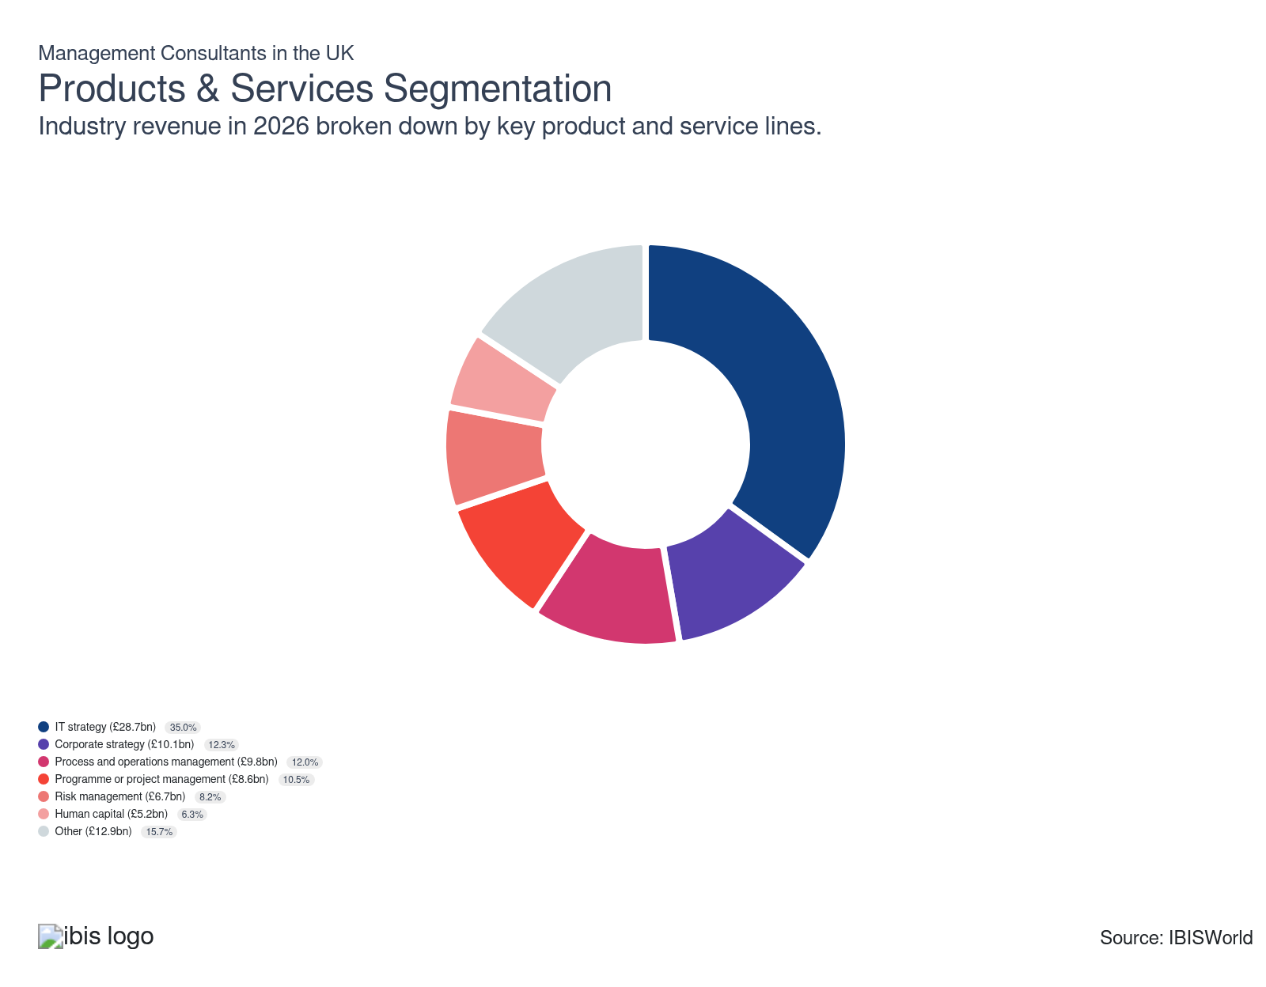

How are the industry’s products and services performing?

IT strategy stands at the forefront of digital transformation
- Digital consulting services have ballooned as data management and IT have become a priority for clients.
- Technology developments are disrupting business models across all industries. Consultants play a key role in helping clients solve issues relating to digital strategy, IT programme management, customer experience digitalisation, app development and robotics process automation.
- The increasing prominence of cloud-based technology and the boom in AI have made IT consulting advice more vital than ever. A recent flurry of acquisitions underscores the growing importance of this segment, with the largest firms bolstering their digital consulting capabilities. Businesses are increasingly seeking consultants to help them from the design stage to the implementation of AI strategies, which is proving a very lucrative revenue avenue.
- The increasing threat of cyberattacks has led companies to seek expert advice. As a result, consultancies are seeking to employ more consultants with standout expertise in this area to gain a competitive advantage.

Corporate strategy comes into focus amid economic challenges
- Corporate strategy consulting focuses on long-term business goals and how best to achieve them. This segment also includes organisational design, which involves reorganising a company to change its operations.
- Corporate strategy is considered a growing segment, as companies are attempting to develop long-term plans for generating sustainable growth and riding out fluctuations in the economy.
- Profit-motivated companies are always seeking strategies to generate cost savings and enhance operational efficiency, regardless of the macroeconomic climate.

Process and operations management is key to weathering economic uncertainty
- Process and operations management consulting relates to the day-to-day functioning of a business, aiming to improve the efficiency and effectiveness of a client's operations.
- Process management services may be small projects targeting particular processes that lack the efficiency to overhaul decision-making within a client's business.
- In response to weakened confidence thanks to economic uncertainty stemming from inflationary pressures, geopolitical tensions and trade war fears, many businesses have focused on immediate issues and cut non-essential management consulting services, including operations consulting.

Demand for programme or project management falters due to economic headwinds
- This segment involves providing advice and knowledge to assist businesses in improving the management of particular projects or programmes.
- Increased complexity in business operations has escalated demand for programme or project management. Stricter regulations and higher risk management standards have amplified the need for expert project managers.
- Subdued business confidence following the surge in inflation and the weakened economic climate has squeezed business expansion and investment projects, with businesses focusing instead on navigating the challenging operating environment . Economic instability has remained amid persistent inflation and prolonged geopolitical tensions and elevated costs faced by businesses, hampering business investment in projects the two years through 2025-26.

Economic difficulties inflate demand for risk management
- Risk management consulting involves highlighting critical areas of risk within a business and developing effective processes with which to deal with them.
- This segment's revenue share has crept upwards as business confidence has fallen, with companies aiming to manage and limit risks from volatile economic conditions, including Brexit, the pandemic, inflationary pressures and geopolitical tensions.
- The adverse economic climate created by persistent inflation, trade fears and continued geopolitical tensions, including the Russia-Ukraine and the Middle East conflicts, have caused difficulties for businesses. These challenges have fuelled businesses’ spending on expert risk management services as companies sought advice on navigating the volatile conditions.

Revenue from human capital consulting climbs as labour shortages persist
- Human capital consulting focuses on advising businesses on effective strategies to get the best out of their labour force. This includes leadership advice, fostering an influential company culture and talent management.
- This segment has achieved particularly pronounced growth in recent years, as an ageing workforce and labour shortages across many sectors of the economy, exacerbated by the UK's new immigration system, have boosted demand for professional advice on HR management.
- A rising trend in remote work has spurred companies to tap management consultants for virtual training and talent development strategies, driving demand for human capital services.
- Ongoing economic uncertainty and the hike in employment costs faced by businesses, partly due to the increases in National Insurance contributions and the National Living Wage, are supporting demand for human capital advice as businesses seek to maintain efficiency amid adverse conditions.

Other services gain headway as consulting services broaden
- Other niche consulting services include economic and regulatory consulting, business transformation consulting, customer and marketing strategy and environmental consulting.
- Business transformation management services involve aiding businesses with transitioning through change.
- Demand for environmental consulting is expanding quickly as regulations relating to energy efficiency and environmental sustainability tighten in line with the government's ambition to transition to a net-zero economy by 2050.
- UK businesses increasingly seek the services of specialist environmental consultants to improve their sustainability credentials. As a result, many consultancies are beefing up their environmental advice teams to cater to the growth in demand.

What are innovations in industry products and services?

The significant growth of tech and IT solutions drives IT strategy requirements
- Any significant technological progress, particularly in the IT sector, is likely to necessitate the development of new and complementary consulting methods. Staff must be aware of and proficient in all new technologies related to their clients' industries.
- There’s soaring demand for expert advice in cybersecurity measures, cloud migration and AI integration from businesses across all sectors of the economy. For instance, analysis from a survey of 100 UK-based law firms by Greenarc reveals that the legal sector places cybersecurity (92%) as the top focus area, followed by cost management (81%) and digital transformation (68%).
- IT solutions and technological innovation in several industries have encouraged many clients to seek innovative solutions to benefit from technological developments in their own sectors.
- Consultancies are expanding their IT strategy teams to benefit from the growing demand for these services. Clients expect tailored solutions that meet their needs. For example, financial firms seek fintech solutions, while retailers are after e-commerce and supply chain optimisation. Consultants must stay on top of tech trends to remain competitive.

Growing demand for big data and technology solutions expands specialised consultancy services
- One significant technological development has been the implementation of software that can sort and analyse large data sets. Firms invest in tools like AI to spot trends and deliver better insights. AI also helps to automate certain mundane tasks, like creating PowerPoint presentations, which frees up time for consultants to focus on more valuable work and human interactions.
- A 2024 Clarity report by Deltek, surveying consultancies based in the UK, Australia and New Zealand, revealed that “improved operational efficiency” and “improved project timeline/delivery” were ranked as the main benefits of AI by 54% and 52% of consultants, respectively.
- Companies are expanding their access to external internet-based libraries and databases for research, as each transaction a retail company conducts generates many statistics. To analyse large statistical sets, consultants must have access to software that can sort and contextualise this information.
- As the amount of data stored digitally expands, companies must devote an increasing proportion of resources towards improving data security, as compromising sensitive client data could result in the loss of business

Consulting on environmental matters presents significant opportunities
- Growing environmental concerns and regulatory pressure are prompting businesses to reevaluate their operations and implement effective strategies to meet sustainability targets.
- Expert consultants can play a major role in this process, offering assessments and strategies for clients to put in place. For example, consultants can help companies integrate greener supply chains, improve energy efficiency and adopt renewable energy.
- Large firms, including Accenture and the Big Four, have dedicated teams in place that provide expert sustainability guidance to clients, giving them an edge in this market. However, with the vast opportunities in environmental consulting, small and up-and-coming firms can also penetrate the market by expanding their specialisation in this service area.
- The UK aims to become net-zero by 2050, with many businesses already implementing green practices to reduce their emissions. Having green credentials makes businesses stand out to increasingly environmentally conscious consumers, with failure to implement sustainable practices potentially leading to reputational damage for businesses. This is propping up demand for environmental consulting.

What products or services do successful businesses offer?
Be an early adopter of new technologies
Successful consultants harness new technologies to provide more insightful advice, create data-driven strategies and improve operational efficiency in their clients’ organisations. Using big data and other forms of tech like AI has proven crucial in tapping into growing consulting services.
Provide a related range of goods and/or services
Offering a wide range of consulting services allows firms to weather economic instability more effectively. Those consultants with expertise in several services can win more projects, boosting revenue.

Major Markets
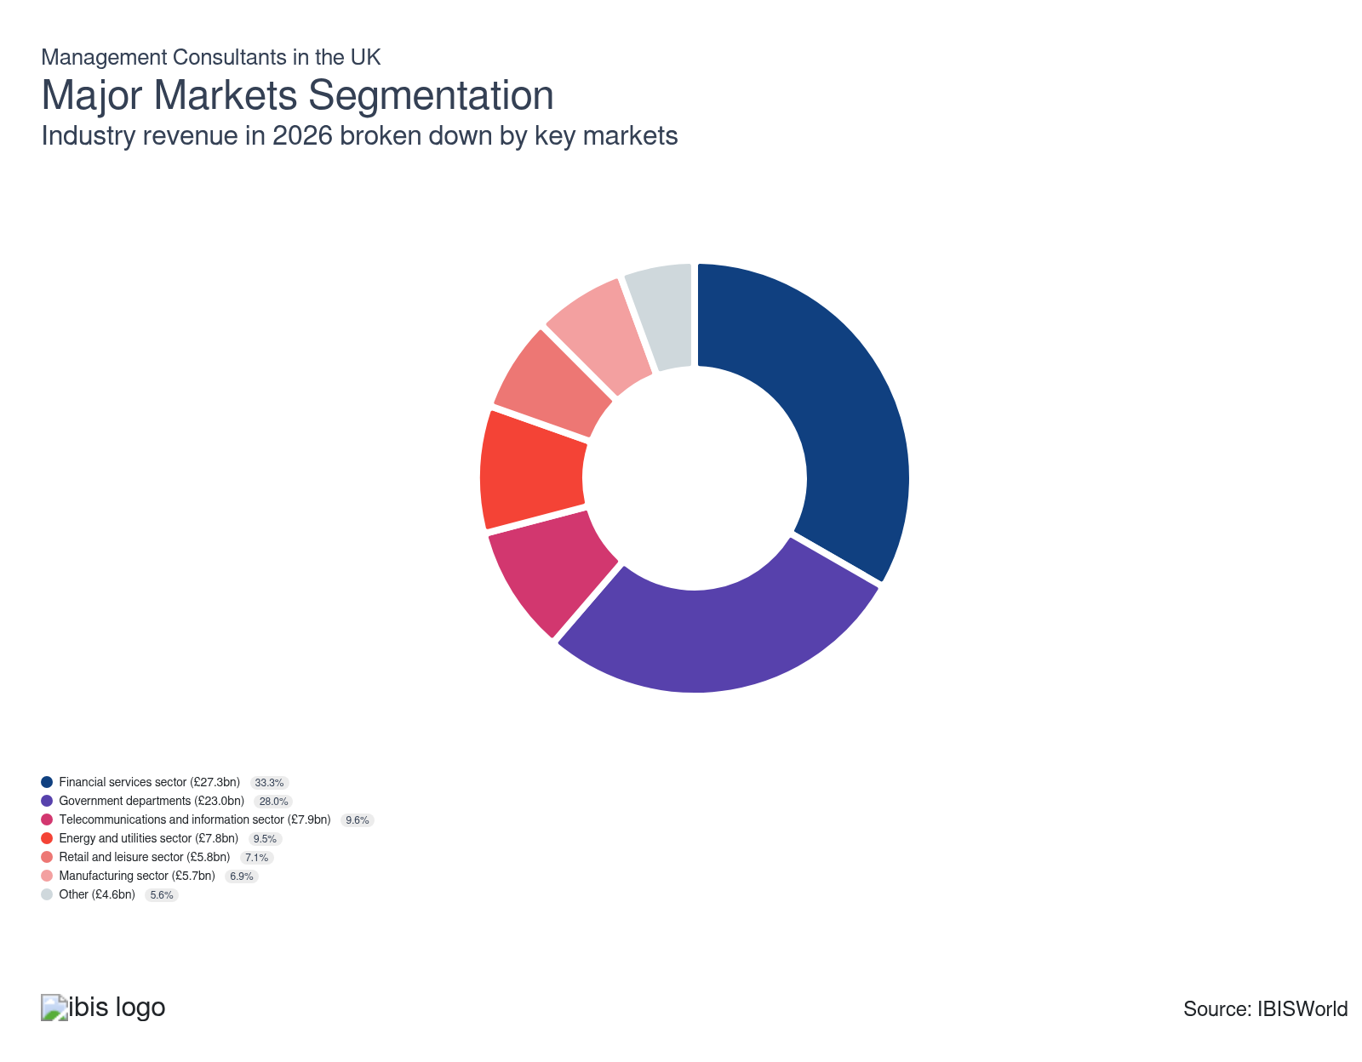

What’s influencing demand from the industry’s markets?

The financial services sector seeks consulting advice on regulatory changes
- The size of the UK financial services sector, with Britain holding a position as a financial hub, and the tendency of financial firms to have complex financial management requirements make it a significant market for management consultants.
- Major international banks, insurers and fund managers regularly employ consultants to help streamline operations and maintain profitability. Meanwhile, many firms in this sector are increasingly seeking advice on digital transformation, including AI strategies and cybersecurity.
- Regulatory changes in the finance sector, including data protection and Consumer Duty rules, have stimulated demand for consulting services, as failure to comply with regulations can result in heavy fines, raising this market’s share of revenue over the past five years.

The government turns to consultants for advice on policy change
- Government spending has been a very important source of revenue for management consultancy since the Brexit vote. The government has made greater use of consultants' services to advise on trade negotiations and help design policy changes, including setting up a new system for customs declarations.
- The government’s ambition to significantly cut spending on external consultants in the coming years threatens revenue from this market. In November 2024, it revealed it aims to cut spending on consultants by £1.2 billion by 2026. Despite this, data from Tussell revealed that large consultancies won government contracts worth £1.5 billion in 2024, up from the £1.4 billion in 2023 and the £1 billion in 2022. Meanwhile, analysis by the Financial Times has found that Home Office spending on consultants reached nearly £230 million in the year through June 2024, compared with just £23.4 million five years earlier.
- Big Four accounting firm KPMG was awarded a £223 million government contract to train civil servants, a deal agreed upon just before plans to cut reliance on external consultants were set out in July 2024. The contract is the second-largest public sector contract awarded to a Big Four firm and shows the lucrative contracts that large, reputable consultancies can win from the government.

Growing demand for communication drives up revenue from the telecommunications and information sector
- Telecommunications is a rapidly changing field influenced by technological change. Demand for management consultants is high because consulting advice is used to develop business strategies. Demand from this market has grown as UK companies have increasingly required advanced telecommunications and information technology.
- London’s position as Europe’s tech hub spurs demand for management consultancy work from businesses in this sector.
- A resilient number of tech startups is expanding the potential client pool for consultants. According to RSM UK, the number of new tech companies in the UK stood at 48,518 in 2024, though 5% below 2023 levels, likely due to the lingering economic adversity.
- Regulatory shifts in data privacy (like GDPR) and online safety (like the Online Safety Act) have spurred demand for management consultancy from telecommunications and information companies in recent years – these businesses have sought advice from experts to ensure compliance.

The energy and utilities sector employs consultants to look at environmental strategy
- Energy and resources have gained the attention of the corporate environment, with corporate social responsibility becoming highly relevant.
- Environmentally friendly production processes, supply chains and procurement have increasingly become integral to businesses' strategies, providing scope for management consultants to offer expert advice. As a result, the energy sector provides a strong demand for environmental consulting services from consultants.
- Clients in this sector are likely to become an increasingly large source of revenue amid the sector's operational restructuring activities, including the shift to green energy and sustainable practices.

Weak operating conditions limit demand from the retail and leisure sector
- This segment includes retail businesses and establishments providing leisure activities, like museums, arcades, casinos, art venues and theme parks.
- The retail and leisure sector has faced significant difficulties in recent years due to changing consumer habits brought about by technological innovation. Consumers are increasingly shopping online while also spending more time and money on entertainment through digital channels.
- Retailers are increasingly using consultants' services to help them develop strategies to respond to digitalisation, which has made online retail and omnichannel selling increasingly important.
- Demand from this market has dipped in recent years, owing to difficulties in the retail sector. Soaring inflation forced consumers to tighten their purse strings while retailers’ operating costs swelled, creating a difficult operating environment and forcing cuts in spending. Although lower, inflation has been creeping up in 2025-26 (at 3.6% in October 2025, as per ONS data), sustaining economic instability. This is hindering consumer and business confidence, ultimately harming revenue from the retail and leisure sectors.

Manufacturing activity remains under strain, restricting spending on consultants
- The manufacturing sector is an important source of demand for management consultants. Manufacturers consistently need advice on maximising efficiency through organisational design and process management and support in navigating changing regulations.
- Import competition, outsourcing and technology use are vital issues in the manufacturing sector, driving demand for consultancy services.
- In recent years, supply chain issues and mounting cost pressures, stemming from the energy crisis, severe inflation and high borrowing costs, have led to budget cuts, limiting manufacturers’ spending on consultancies.
- Continued geopolitical tension, trade war fears and elevated costs sustain heightened economic uncertainty, hindering manufacturing activity and squeezing budgets. The ONS reports that annual production output contracted by 1.7% in 2024, with manufacturing output dipping by 0.7%. Manufacturing output has continued to struggle in 2025-26, with the ONS reporting that output dropped by 0.8% in the three months to September 2025 compared to the prior three-month period. At the same time, though, these challenges are supporting demand for countercyclical services like risk management.

Work on large infrastructure projects often involves consultants' advice
- Other businesses that use the services of management consultants include those working in the infrastructure and transport sectors.
- Companies working in infrastructure often require advice from consultants about the complexity of major projects.

International Trade

Some industries don't directly import or export goods. See reports at the manufacturing level for international trade data on relevant products.

5. Geographic Breakdown
https://my.ibisworld.com/uk/en/industry/M70.229/geographic-breakdown

Key Takeaways
- London is the UK’s commercial hub. The capital is home to many management consultants, including all major international consulting companies, due to its leading share of business activity.
- The South East reaps the benefits of its proximity to London. The region boasts cheaper rent costs than London, though it remains near the financial capital, presenting firms with access to many clients and lucrative work.

Business Locations
Region | Establishments (Units)  2026 | Establishments (%)  2026 | Establishments (YoY Growth %)  2026 | Population (%)  2026
South West | 15238 | 7.6 | 0.0 | 8.5
South East | 40302 | 20.1 | 0.0 | 14.0
Wales | 4211 | 2.1 | 0.0 | 4.6
North West | 16441 | 8.2 | 0.0 | 11.2
Northern Ireland | 1805 | 0.9 | 0.0 | 2.7
Scotland | 10426 | 5.2 | 0.0 | 7.8
East Midlands | 11228 | 5.6 | 0.0 | 7.4
Yorkshire | 10426 | 5.2 | 0.0 | 0.0
East of England | 20051 | 10.0 | 0.0 | 0.0
London | 53936 | 26.9 | 0.0 | 13.1
North East | 3609 | 1.8 | 0.0 | 4.0
West Midlands | 13033 | 6.5 | 0.0 | 8.9

Where are industry businesses located?

London is the financial capital of Europe
- London, as the commercial hub of the UK, is the focal point for management consulting practices. All of the major international consulting firms, including Accenture and the Big Four, have locations in the capital. Many firms position themselves in and around the city centre, giving them proximity to major clients.
- There are many important clients in the capital, including financial services companies, communications businesses and government departments. This provides reliable demand alongside lucrative project work for consulting firms located in London.
- London accounts for the country's highest share of economic activity, attracting large consultancies to the capital. According to the Business statistics research briefing released by the House of Commons, it has the highest number of businesses, at around 983,000 in January 2024. The city also boasts a highly diversified and well-educated pool of talent, providing firms with the required staff.
- Although maintaining its leading position, London’s dominance has been challenged over the past decade as businesses have expanded beyond central London into surrounding areas and expanding urban centres like Manchester in the North West to cater to the growing number of businesses there.

The South East offers access to the capital’s market at a lower cost
- The South East region is home to numerous leading and innovative businesses and has the second-highest level of economic activity in the UK. According to Department for Business & Trade data, the South East housed 907,000 private sector businesses. This concentration of organisations commands a large number of management consultancies to support business operations.
- Its proximity to the UK capital and strong transport links offer strategic advantages, enabling swift access to London’s global clientele without incurring the capital's operating costs.
- The South East's affluent counties, including Surrey, Oxfordshire, Buckinghamshire and Berkshire, attract management consultancy companies to the region. These areas are home to some prominent businesses that have greater resources and can afford to spend more on management consulting services.

The East of England is cheaper and close to financial districts
- The East of England boasts a thriving business scene with a vast array of industries requiring expert advice for management issues. The region’s thriving science and technology corridor draws specialist consultancies focused on organisational transformation for fast-growing tech firms and startups.
- The region's proximity to London and availability of talent from well-established universities (like the University of Cambridge and the University of East Anglia) aid consultancies located in the region.
- Rent costs are cheaper than in the capital and the South East, encouraging smaller companies to operate in the East of England. Some management consultancy establishments looking to cut back expenditure have relocated to the East of England.
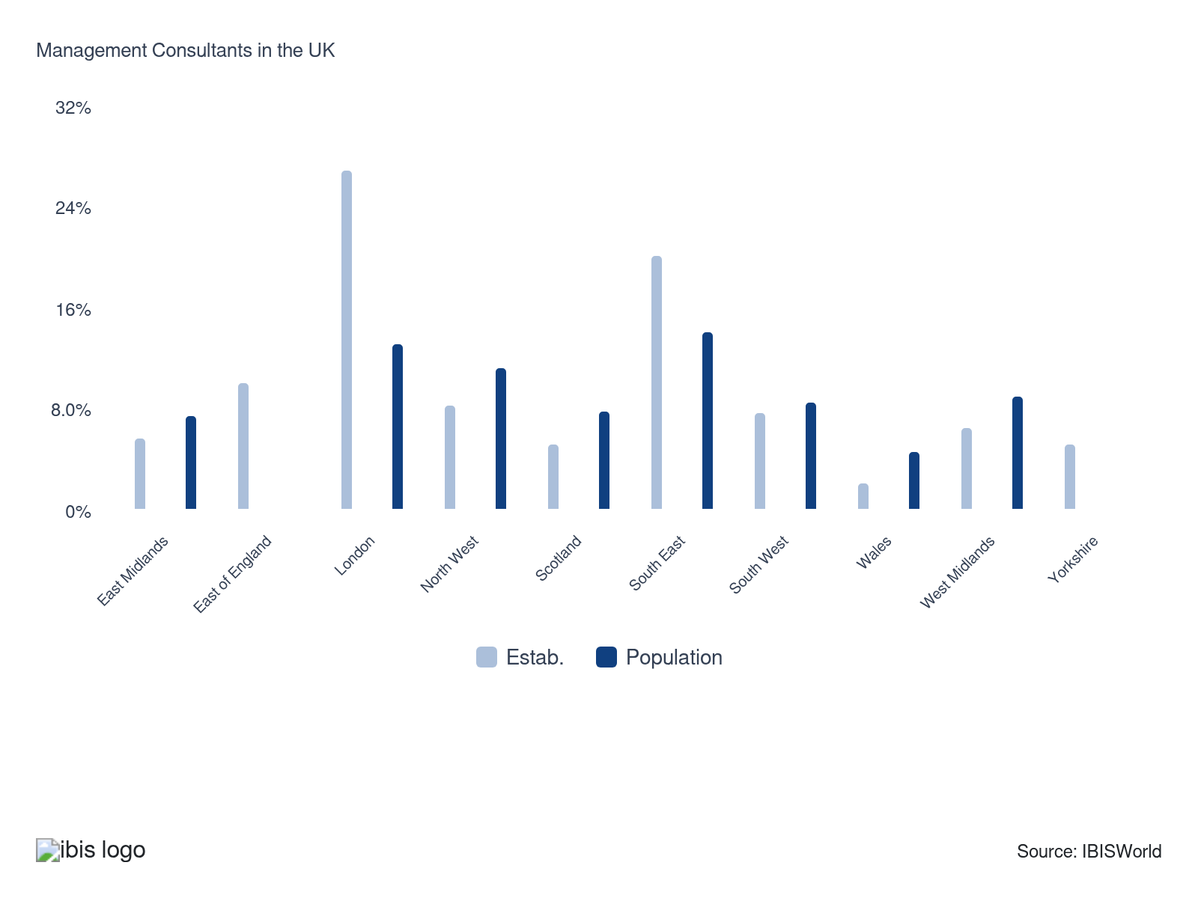

How do businesses use location to their advantage?
Operate in a location that is close to key markets
Firms strategically position themselves close to economic hotspots, like the City of London. This allows them to benefit from increased exposure to potential clients, expanding their service reach and bolstering relationships with existing customers.
Align cost-effective delivery with client needs
Successful consultants excel at delivering tailored, cost-effective solutions. Their strategic location allows them to easily tap into local knowledge and trends, ensuring value for their clients.
Provide easy access to clients
Successful management consultancy firms ensure convenient access to their consultancy services. Ensuring easy access can expand a firm’s client base, supporting revenue.

6. Competitive Forces
https://my.ibisworld.com/uk/en/industry/M70.229/competitive-forces

Key Takeaways
- Leading consultancy firms have strengthened their positions through consolidation. Larger management consultants have engaged in consolidation activity to expand their capabilities, particularly in digital solutions, and solidify their presence in the industry.
- The range of management consultant services is broad. In recent years, this has opened up opportunities for external competition. With a big emphasis on IT consulting, computer consultants have become a more prominent external threat to management consultants.

Concentration
Low
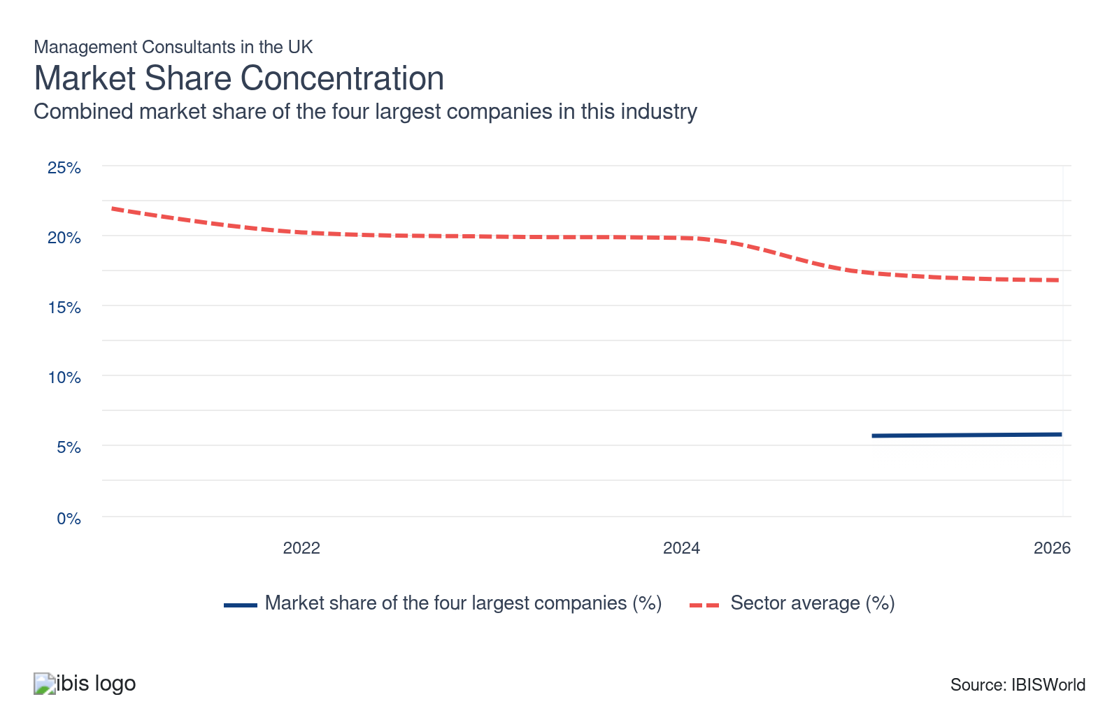

What impacts the industry’s market share concentration?

Low entry barriers and demand opportunities encourage companies to dip their toes into the industry
- The industry mainly consists of independent contractors and specialised boutique consulting services, resulting in high fragmentation.
- One of the main reasons for the significant number of small companies in the industry is the ease with which new consultancies can be established – legal barriers and start-up costs are fairly low.
- As the industry has broadened its services, many consultants have opted to specialise in specific industries and niche markets, like environmental consulting and cybersecurity solutions, instead of offering comprehensive strategic services, opening the market to individuals with industry-related knowledge. This trend for highly specialised and tailored services allows many independent firms to win contracts, holding concentration down.
- The more prominent industry firms, including the Big Four, have faced climbing costs and recent scandals that have damaged their reputations, like the Big Four’s major audit failures and Boston Consulting Group’s Gaza scandal, leaving clients seeking alternatives. This has encouraged new entrants into the market seeking to capitalise on opportunities. For instance, a new advisory firm, Unity Advisory, was launched in the UK in April 2025 by former senior executives from EY and PwC. The firm is backed by private equity firm Warburg Pincus, with a focus on mid-sized businesses and providing AI-driven solutions.

Consolidation activity raises the presence of the most prominent consultancies
- Larger consultancy companies have sought to strengthen their influence and protect their market share through consolidation, eroding competition from independent consultancies over the past five years.
- Specialised management consultants have become a more recent target for takeover as significant trends like IT consultancy and AI ramp up the need for total coverage of consulting services.
- Global giant Accenture has been at the forefront of acquisition activity, taking over smaller firms specialising in tech consultancy. Some of its more recent acquisitions in the consultancy space include that of UK technology consultancy 6point6, which specialises in cloud, data and cybersecurity, in January 2024; and data consultancy Redkite in December 2023 to boost its data and AI offerings in the UK. Accenture also acquired financial services and digital transformation management consultancy Altus Consulting and global construction consultancy services provider Soben in March 2025. Such acquisition behaviour will likely continue in the coming years as the company seeks to boost growth, increasing concentration slightly.

Large firms boast significant expertise and win substantial public work
- There are several large firms within the industry, though their market shares remain small. These include the Big Four accounting firms (PwC, EY, KPMG and Deloitte) and dedicated global management consulting firms like McKinsey & Company, Boston Consulting Group and Bain & Company. Accenture is a leading firm thanks to its expertise in digital transformation.
- Many clients prefer working with smaller, specialised boutique firms for their agility and tailored solutions. Nonetheless, larger firms leverage their size and resources to win contracts, particularly lucrative government work. Data from Tussell revealed that large consultancies won government contracts worth £1.5 billion in 2024, up from £1.4 billion in 2023 and £1 billion in 2022.
- The significant resources invested in AI, combined with the ability to attract talent through substantial pay packages, can help larger firms gain a competitive edge and deliver more valuable, tech-driven solutions to clients.

How do successful businesses handle concentration?
Leverage business expertise
Top-notch consultancy firms combine vast industry knowledge and expertise to provide tailor-made solutions. This enables them to maintain a competitive edge and obtain a large market share.
Hire an experienced workforce
By employing seasoned professionals, consultancy firms deliver high-value advice based on extensive experience, sustaining loyalty among existing clients and attracting new ones to maintain their market concentration.
Develop a strong reputation
Consultancy firms with stellar reputations for high-quality work are trusted by businesses, securing a significant chunk of the market share.

Barriers to Entry
Low | Steady

What challenges do potential industry entrants face?

Legal
- The degree of regulation covering management consultants is minimal, meaning there are no prohibitive legal barriers and making entry into the industry easier. Firms don’t face heavy regulations, while accreditation, like the Chartered Management Consultant (ChMC), isn’t mandatory, though it can boost a consultancy’s credibility.

Start-Up Costs
- Establishing a new management consultancy company requires little capital, as evidenced by the sizeable number of SMEs in the industry. Potential entrants can lease office space and equipment to lower initial costs. Meanwhile, marketing costs are also low. The minimal initial outlay encourages new entrants to the industry.

Differentiation
- Building a solid reputation and establishing long-lasting relationships with clients is fundamental to success, as repeat business is pivotal. The high number of consultants offering similar services raises barriers to entry. Companies that can specialise in niche markets, like environmental consulting or digital transformation, and can create unique selling propositions are more likely to be successful.

Labour Expenses
- Management consultancy companies require highly qualified and experienced individuals to provide consulting services. Consultants will often possess postgraduate qualifications and degrees, including MBAs. Employees require high salaries, reflecting their qualifications and experience, which raises labour expenses and can be a barrier for potential entrants.

How can potential entrants overcome barriers to entry?
Provide development programs for personnel
The quality of staff at a consultancy is critical to client satisfaction. While many consultants bring specialised skills in a given field, many consulting-specific abilities must be learned.
Be willing to outsource when appropriate
Consultancies should have access to subcontracted employees with specialist skills to offer a broader range of services to clients and assist in managing overheads.
Have a diverse range of clients
Serving a broad client base reduces dependency on any single sector, making new entrants more resilient. Serving businesses with varied needs ensures a greater chance of success and growth.

Substitutes
Moderate | Increasing

What are substitutes for industry services?

Computer Consultants
- As management consultants increasingly move into IT consulting and digital transformation solutions, competition from the Computer Consultants industry poses a greater threat.
- Computer consultants can offer a more tech-focused perspective than traditional management consultants, luring clients away from the industry.
- The integration of digital technologies into day-to-day operations and data management innovations have driven up demand for IT strategy, causing computer consultancy to gain headway as fierce competition to consulting services. With digital transformation, including cloud migration and cybersecurity strategy, being a top priority for businesses, the expertise and bespoke solutions of computer consultants are proving invaluable, particularly as they can offer competitive fees.

In House
- The importance of consulting services has led many companies to form in-house management consultancy departments. In-house teams possess a greater understanding of company culture and processes, allowing them to implement solutions faster and more effectively.
- Businesses have set up in-house teams to cut costs on pricey external management consultants and reduce their reliance on them. This has been exacerbated by economic instability and inflationary pressures inciting a desire from companies to cut spending where possible.
- The success of in-house consulting is varied. Many companies still prefer to outsource consulting services as they want to focus on core tasks and due to the sizeable loyalty and success of many prominent management consultants. Some companies also turn to consultancy firms for niche expertise or major transformations, as external professionals can provide high-value, innovative solutions.

How do successful businesses compete with substitutes?
Raise revenue from additional sources
Following the trend of convergence in general management consulting and IT consulting that resulted from developments in the digital economy, providing additional consulting segments gives companies a competitive advantage.
Develop a loyal customer base
Developing long-term clients is crucial in preventing substitutes from eroding consulting client bases. Consultants can achieve this by consistently providing high-quality, tailored services, leading to greater client satisfaction and repeat business.

Buyer & Supplier Power
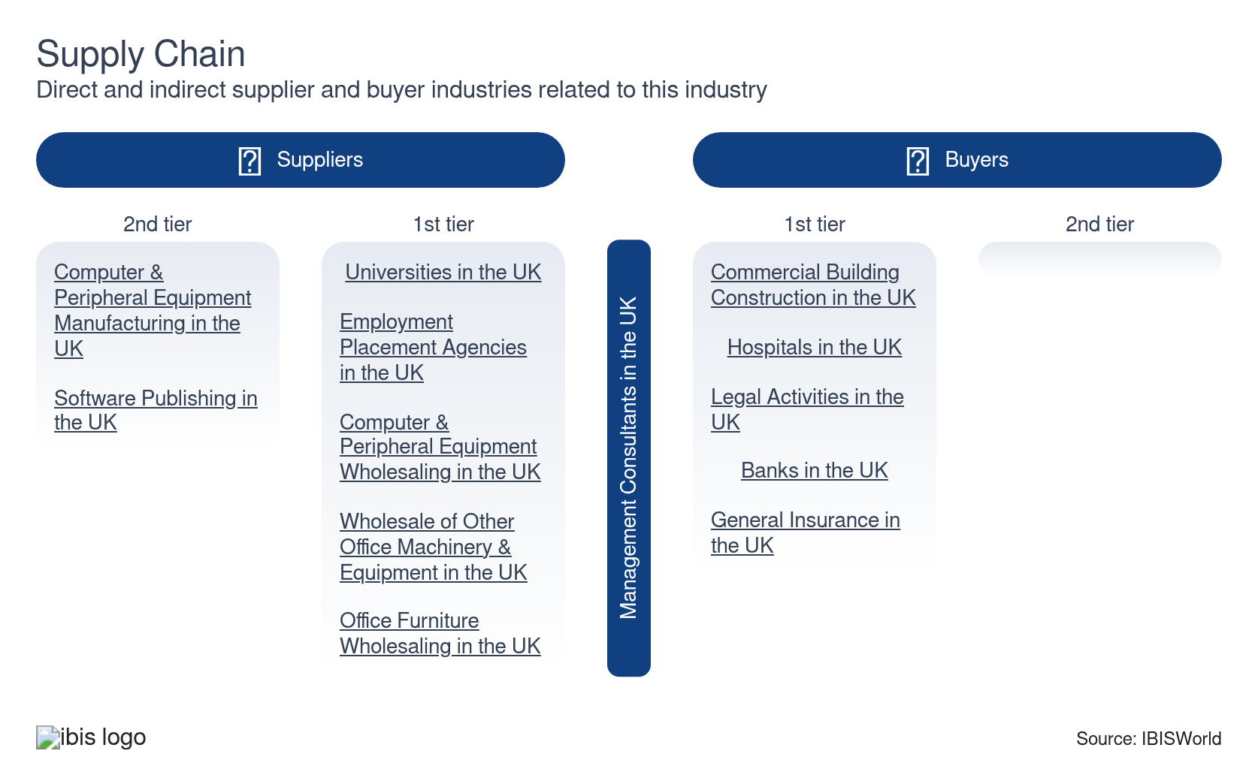

What power do buyers and suppliers have over the industry?

Buyers: A solid reputation is key to attracting clients
Moderate | Increasing
- Clients typically choose management consultant companies based on their reputation and existing client base. Price is less critical when it comes to large consultancy companies that boast extensive expertise and a proven track record to justify higher fees.
- Businesses have a large pool of management consultancy firms to choose from, giving them more power. However, businesses with complex needs and in need of specialised advice may have to be price-takers to secure the services of experienced, knowledgeable consultants.
- Some clients may become more conscious of spending during weak economic periods, like with recent inflationary pressures and economic instability, putting pressure on consultants to cut prices; however, the management consultant's role amid uncertainty is often pivotal in business strategy, preventing many clients from cutting back on consulting services.

Suppliers: Workforce requirements drive supplier power
Moderate | Increasing
- The Management Consultants industry heavily relies on highly skilled staff to communicate and aid clients in their consulting projects. A sufficient number of staff with varied skills is vital due to the numerous services provided by consultancies.
- A shortage of skilled labour in Britain, significantly exacerbated by Brexit, is posing issues for firms, forcing them to offer more attractive pay packages to retain and win talent.

How do successful businesses manage buyer & supplier power?
Possess accurate information
Access to valid and reliable data is crucial, as data forms the foundation of a consultant's decision-making process. Inaccurate information can lead to bad advice and ruin client relationships.
Effectively communicate and negotiate
Strong presentation skills, particularly in relation to client report presentations and for tenders, are key to consultancies’ success.
Align cost-effective delivery with client needs
Providing flexible, cost-effective solutions that are tailored to clients' needs can enhance a consultancy’s appeal, strengthening its position in negotiations and diminishing buyer power.

7. Companies
https://my.ibisworld.com/uk/en/industry/M70.229/companies

Key Takeaways
- The Management Consultants industry is highly fragmented. There’s a significant number of independent and boutique consultancy services. Even the most prominent management consultancies only hold a minimal share of the market.

Market Share
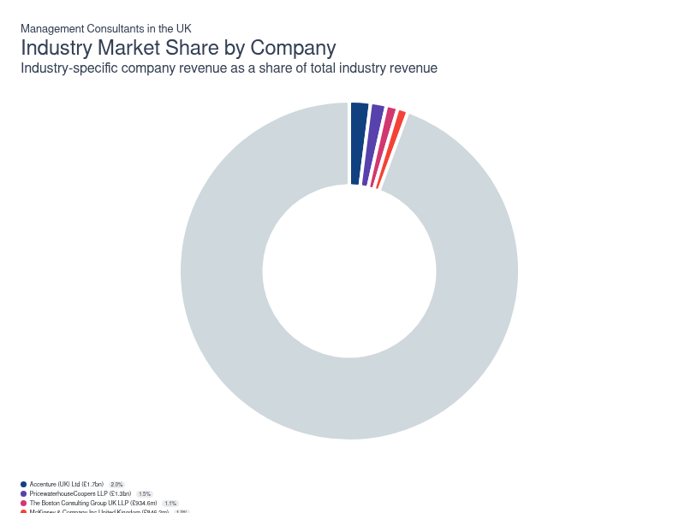
Chart displays current year only in the PDF version of this report. You can view and download chart for all other years associated with this industry on my.ibisworld.com.

Companies
Company | Market Share (%)  2026 | Revenue (£m)  2026
Accenture (UK) Ltd | 2.0 | 1,677.9
PricewaterhouseCoopers LLP | 1.5 | 1,257.8
The Boston Consulting Group UK LLP | 1.1 | 934.6
McKinsey & Company Inc United Kingdom | 1.0 | 846.2
Deloitte LLP | 0.9 | 741.6
KPMG LLP | 0.7 | 578.6
Ernst & Young LLP | 0.7 | 559.0

Accenture (UK) Ltd
Accenture (UK) Ltd
Company Details
Company Details
Industry Specific Revenue (2026) | £1.7bn
Market Share (2026) | 2.0%

Description
Description
Accenture plc is one of the world's leading management consulting, technology services and outsourcing organisations. It's headquartered in Dublin. The company grew from the collapse of Arthur Anderson Consulting in the wake of the Enron scandal in 2001. It operates in the UK through its Accenture (UK) Ltd subsidiary, which was founded in 2003 and is headquartered in London.

Other Industries
Other Industries
- Financial Management in the UK
- Business Process Outsourcing Services in the UK
- Healthcare Consultants in the UK
- Marketing Consultants in the UK
- SEO & Internet Marketing Consultants in the UK
- Computer Consultants in the UK
- Procurement Outsourcing Services in the UK

Company’s Industry Revenue, Market Share, and Profit Margin Over Time
Company’s Industry Revenue, Market Share, and Profit Margin Over Time
Year | Industry Revenue ($ million) | Market Share (%)
2024-25 | 1605 | 2.0
2025-26 | 1678 | 2.0

What's impacting Accenture (UK) Ltd's performance?

Acquisitions accentuate Accenture’s revenue growth
- Accenture has expanded its revenue through inorganic growth. It’s been involved in strong acquisition activity to enhance its capabilities and cement its position in the market, particularly in digital consulting solutions.
- Accenture acquired Mudano Ltd, a data and machine learning business focused on the financial sector, in 2020, aiming to strengthen its understanding of the growing significance of AI and tech. In February 2021, Accenture acquired SAP consultancy Edenhouse and cloud and digital transformation consultancy Infinity Works, bolstering its digital consultancy capabilities as COVID-19 accelerated the need for digital transformation.
- In September 2023, Accenture acquired Nautilus Consulting, a leading UK digital healthcare consultancy. In December 2023, UK data consultancy Redkite also became part of Accenture. In January 2024, Accenture completed the acquisition of 6point6, a UK-based technology consultancy specialising in cloud, data and cybersecurity, in January 2024. It took over Objectivity, a company specialising in cloud and platform development services, in March 2024.
- Acquisition activity shows no signs of slowing in 2025, as Accenture acquired Altus Consulting, a financial services and digital transformation management consultancy firm; and Soben, a global construction consultancy services firm, in March 2025. The company will likely continue its expansion through acquisitions as it aims to further expand its digital capabilities and reach in the market.

Digital transformation strategies establish Accenture's position in expanding markets
- Accenture's strategic focus on digital transformation has boosted demand from emerging markets such as AI, cybersecurity and other innovative systems. This has been supported by inorganic growth and partnerships with tech-based companies to provide Accenture with the suitable building blocks for this change, allowing for the market leader to create a buffer against economic uncertainty.
- Despite its statute in the market and standout capabilities, the company wasn’t immune to the slowdown in demand from clients in 2023-24 amid a challenging economic market, including geopolitical tensions and higher interest rates. This contributed to a dip in revenue over the year to August 2024.
PricewaterhouseCoopers LLP
PricewaterhouseCoopers LLP
Company Details
Company Details
Industry Specific Revenue (2026) | £1.3bn
Market Share (2026) | 1.5%

Description
Description
PricewaterhouseCoopers (PwC) is the world's largest professional services companies. It operates as a network of companies, with each acting independently in its geographic jurisdiction. PwC was formed when Price Waterhouse merged with Coopers & Lybrand in 1998. Its UK headquarters are in London.

Other Industries
Other Industries
- Financial Management in the UK
- IT Security Consulting in the UK
- Accounting & Auditing in the UK
- Tax Consultants in the UK
- Healthcare Consultants in the UK
- Marketing Consultants in the UK
- Actuarial Consulting Services in the UK
- Forensic Accounting Services in the UK

Company’s Industry Revenue, Market Share, and Profit Margin Over Time
Company’s Industry Revenue, Market Share, and Profit Margin Over Time
Year | Industry Revenue ($ million) | Market Share (%)
2024-25 | 1239 | 1.5
2025-26 | 1258 | 1.5

What's impacting PricewaterhouseCoopers LLP's performance?

Consulting makes up a significant portion of PwC's revenue
- PwC LLP splits its services into five main groups: risk assurance services; audit services; tax services; consulting services; and deal services. In the 12 months through June 2025, consulting made up £1.9 billion (31.2%) of total revenue. Tax services, including direct and indirect tax services to private and corporate clients, generated £1.2 billion (19.3%), while audit services generated £1.5 billion (23.5%) of total revenue. Risk assurance made up £596 million (9.4%) of revenue. Deal services accounted for just under £1.1 billion (16.5%) of total revenue.
- Despite a more challenging economic climate since the second half of 2022, the company recorded resilient demand from businesses and the public sector in the two years through 2023-24. However, PwC reported a significant slowdown in revenue growth in the year to June 2025. Tougher economic conditions and weaker demand contributed to the slowdown. The firm's consulting revenue took a hit, falling by approximately 3%. Despite this, profit has expanded.
- The Financial Times reported in October 2024 that PwC plans to restructure its UK operations by launching a "digital delivery unit." This unit will affect 2,700 staff and will focus on innovation, AI engineering, cloud and data. It will also change parts of its consulting, risk, deals and tax segments.
- In November 2025, PwC UK announced that it had signed a multi-year, multi-million-pound deal with Palantir to support the latter's clients in adopting its technology for AI transformations across the UK. This will boost the company's consulting segment.
The Boston Consulting Group UK LLP
The Boston Consulting Group UK LLP
Company Details
Company Details
Industry Specific Revenue (2026) | £934.6m
Market Share (2026) | 1.1%

Description
Description
The Boston Consulting Group (BCG) UK LLP is a subsidiary of the global management consulting firm Boston Consulting Group, Inc. The US-based giant was founded in 1963 and boasts over 33,000 employees in over 50 countries. In the UK, it has four offices, all of which are in London.

Company’s Industry Revenue, Market Share, and Profit Margin Over Time
Company’s Industry Revenue, Market Share, and Profit Margin Over Time
Year | Industry Revenue ($ million) | Market Share (%)
2024-25 | 881 | 1.1
2025-26 | 935 | 1.1

McKinsey & Company Inc United Kingdom
McKinsey & Company Inc United Kingdom
Company Details
Company Details
Industry Specific Revenue (2026) | £846.2m
Market Share (2026) | 1.0%

Description
Description
McKinsey & Company is a US management consulting firm founded in 1926. In the 1980s and 1990s, the firm expanded internationally and established new practice areas. McKinsey & Company provides strategy and management consulting services, such as providing advice on an acquisition, developing a plan to restructure a sales force, creating a new business strategy or providing advice on downsizing. Its consultants design and implement studies to evaluate management decisions using data and interviews to test hypotheses.

Other Industries
Other Industries
- Healthcare Consultants in the UK

Company’s Industry Revenue, Market Share, and Profit Margin Over Time
Company’s Industry Revenue, Market Share, and Profit Margin Over Time
Year | Industry Revenue ($ million) | Market Share (%)
2024-25 | 831 | 1.0
2025-26 | 846 | 1.0

Deloitte LLP
Deloitte LLP
Company Details
Company Details
Industry Specific Revenue (2026) | £741.6m
Market Share (2026) | 0.9%

Description
Description
Deloitte LLP, founded in 1845 and headquartered in London, is the UK affiliate of Deloitte NSE LLP, a member firm of Deloitte Touche Tohmatsu Limited, a UK private company limited by guarantee. They provide audit and assurance, consulting, tax and related services. Specifically, their consulting services provide company solutions using new technology shaped by industry insights. Part of this includes providing enterprise technology and performance solutions.

Other Industries
Other Industries
- Tax Consultants in the UK
- Financial Management in the UK
- Accounting & Auditing in the UK
- Healthcare Consultants in the UK
- Marketing Consultants in the UK
- Actuarial Consulting Services in the UK
- Forensic Accounting Services in the UK
- Computer Consultants in the UK

Company’s Industry Revenue, Market Share, and Profit Margin Over Time
Company’s Industry Revenue, Market Share, and Profit Margin Over Time
Year | Industry Revenue ($ million) | Market Share (%)
2024-25 | 738 | 0.9
2025-26 | 742 | 0.9

What's impacting Deloitte LLP's performance?

Deloitte has expanded its consulting division, but takes a hit from the recent slowdown in demand
- Like other Deloitte partner firms worldwide, Deloitte LLP has been actively boosting its consulting practice by acquiring other consulting businesses. For example, in January 2023, it completed the acquisition of London tech consultancy Reformis. The company generates most of its revenue through its consulting segment.
- Deloitte has been expanding its consulting services into high-growth sectors such as technology and innovation, building strategic partnerships with technology companies to better tackle the digital transformation many clients must manoeuvre through.
- Consultancy work slowed in 2023-24 as high interest rates and geopolitical tensions created an adverse economic climate, which put potential clients off from investing in consultancy services. Despite this slowdown, the company has reported continued demand for business transformation, cloud migration, technology modernisation, data and analytics.
- In 2024-25, the firm reported a 1% dip in revenue for the first time in 15 years, driven by a slowdown in its consulting segment, which contracted by 10% amid businesses holding back on investments in change programmes. Deloitte reported plans to reduce its regional deal advisory unit as it's not producing the expected returns, with the profit margin being lower than on big deals, especially given the quiet market conditions. The firm wants to focus on larger, sector-specific merger and acquisition activity.

You can view and download company details on my.ibisworld.com.

8. External Environment
https://my.ibisworld.com/uk/en/industry/M70.229/external-environment

Key Takeaways
- Low business confidence levels dilute business activity. Weakened business optimism typically lowers demand for advice on business strategy and expansionary activities, hampering management consultants’ performance.
- The number of businesses heavily influences demand. The number of businesses is a good indication of the potential demand for consultancy services. When there are more businesses, the potential client pool expands, with demand for management consulting generally following suit.

External Drivers

What demographic and macroeconomic factors impact the industry?
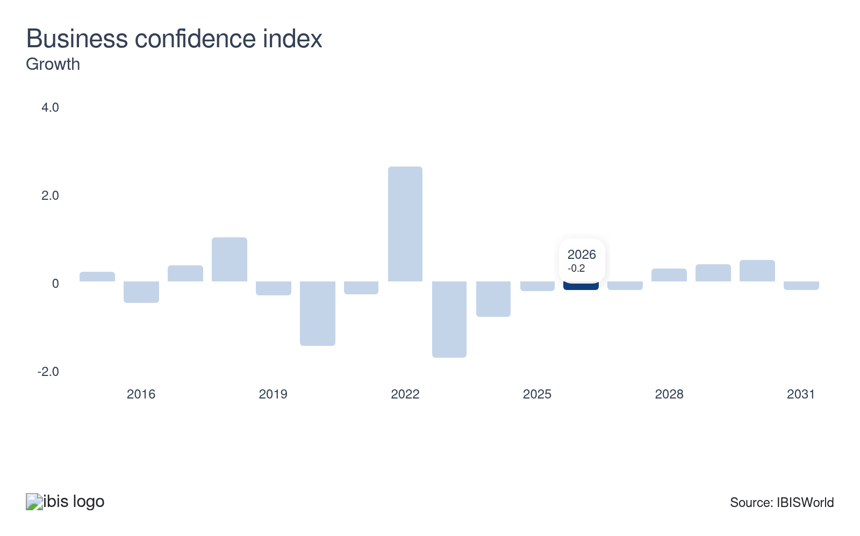
The willingness of businesses to invest in either capital or services is closely related to their confidence. When businesses are confident about economic conditions, they invest more in management consultants to bolster operations. In uncertain times, subdued business confidence often means companies tighten their belts and may limit spending on consultancy services. However, sometimes businesses seek consultants for services like cost cutting, restructuring and risk management, as they need advice to weather challenges caused by economic downturns.
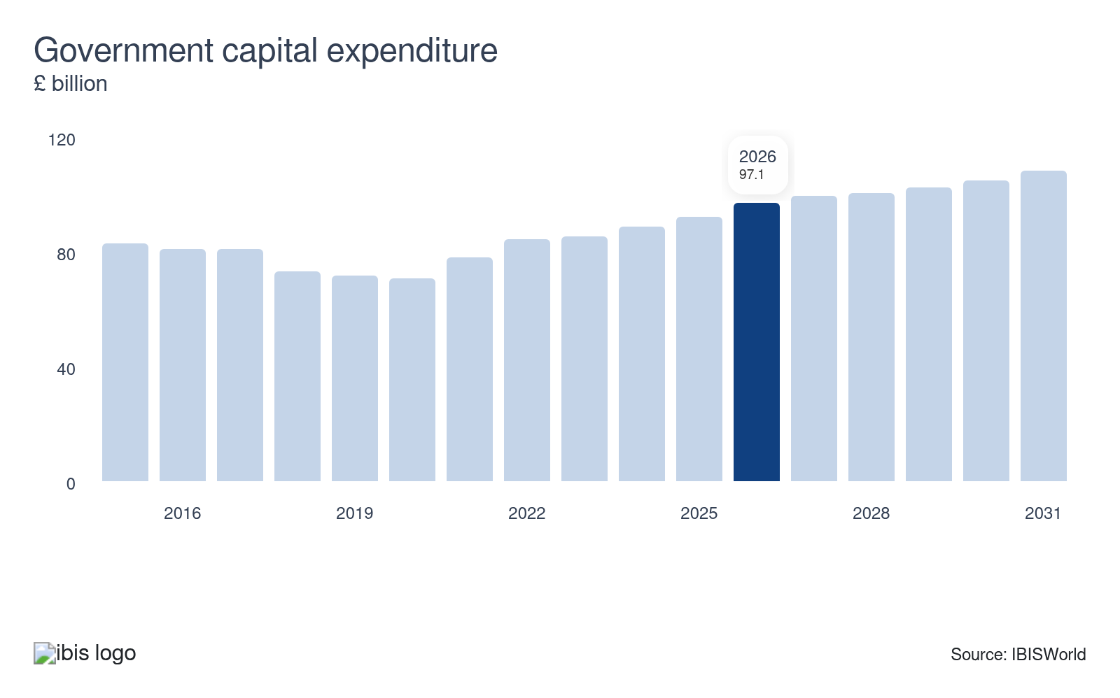
Government capital expenditure can be used as a proxy for how much the government is spending on outsourced business services. When government spending increases, particularly on projects that require strategic planning and operational management, demand for management consultants often rises. However, growing pressure to reduce government expenditure on pricey external consultants poses a threat to management consultancy firms.
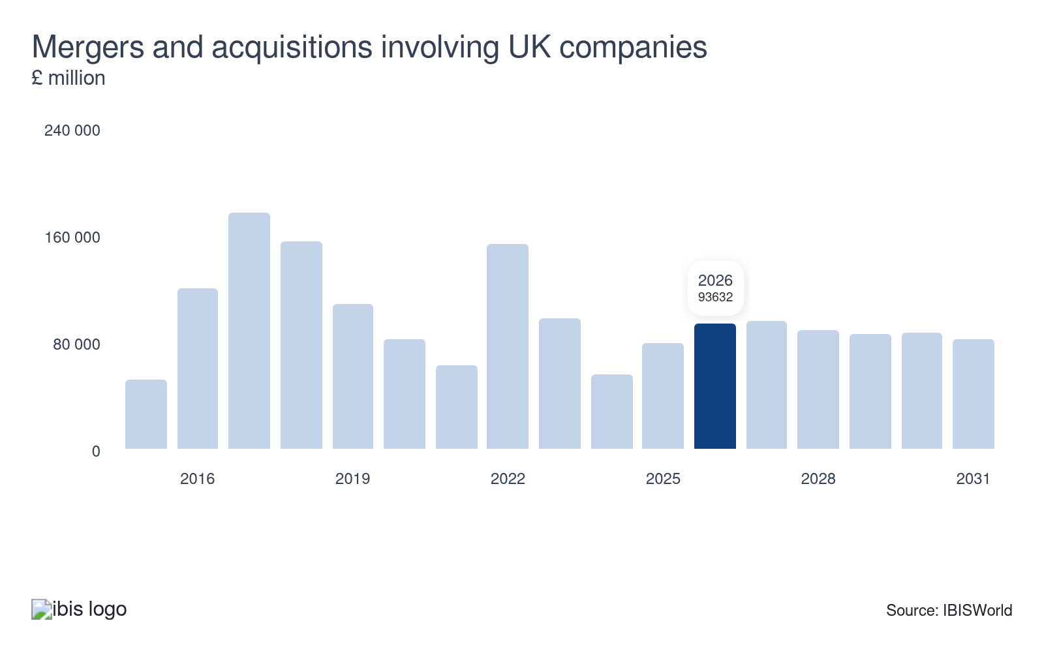
Management consultants play a vital role in developing M&A business strategies, including target search and selection. The complex nature of M&A activities often necessitates expert advice, boosting demand for consultants. M&A activity is largely dictated by economic conditions, with economic headwinds weakening deal-making. Shrinking M&A activity can significantly curb demand for consultants.
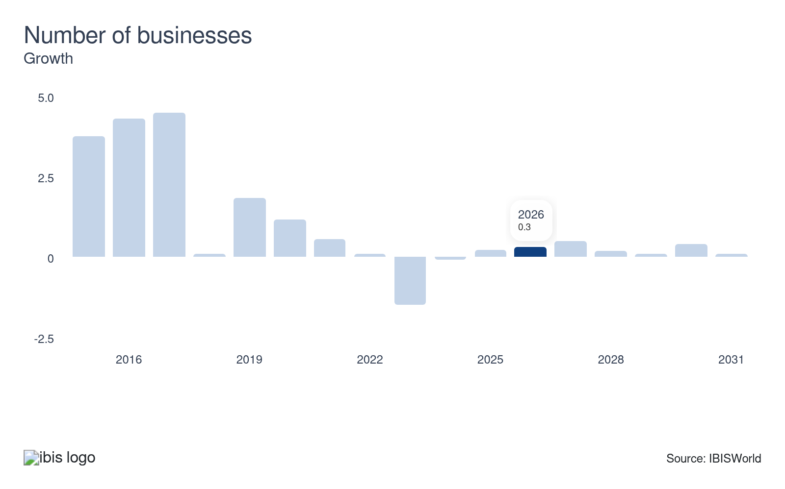
The number of businesses in the UK indicates the potential demand for consultancy services. As the number of companies climbs, the potential client pool expands, which raises demand for management consulting. More businesses means greater demand for expert advice on strategic planning, marketing and HR. A drop in the number of businesses means fewer potential clients for management consultancies, hindering revenue.
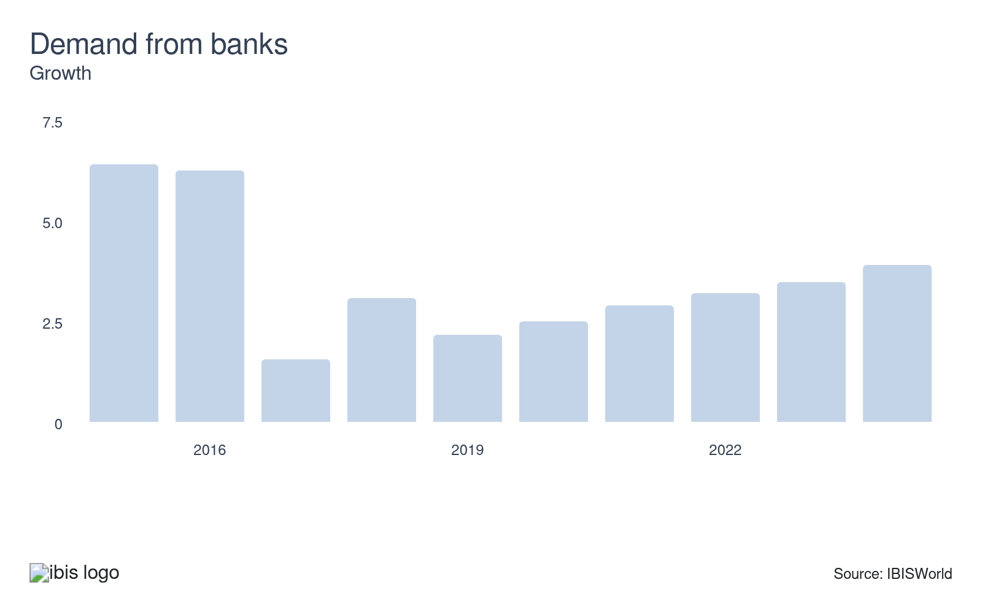
Finance companies are one of the largest markets for management consultants. Banks often lean on management consultancy firms for strategic and organisational planning, particularly amid industry changes or regulatory shifts. An uptick in banks seeking external expertise can drive significant growth for management consultants, while a downturn in banking activities may negatively impact demand.
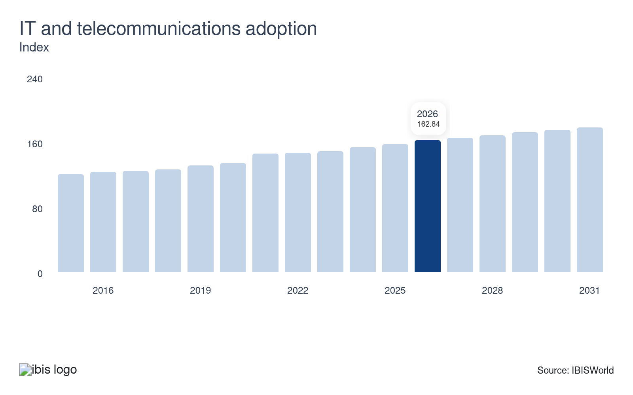
The ongoing digital transformation of many work practices drives demand for management consultants. Businesses implementing IT and telecommunications systems will often turn to management consultants to streamline this digital shift. IT strategy accounts for the largest share of management consultants’ revenue. Consistent growth in IT and telecommunications adoption presents significant growth opportunities for management consultancy firms.

Regulation & Policy
Low | Increasing

What regulations impact the industry?

Management Consultancies Association (MCA)
The MCA is the leading professional body governing management consultants in the UK. The MCA requires members to observe a code of professional conduct and membership is restricted to practising consultants. The quality of management consultants has been far less regulated than in other professional service industries, like accounting and legal services. However, the MCA has developed a unifying professional standard through a Chartered Management Consultancy Award.

EU Audit Regulation and Audit Directive 2016
The regulation imposes mandatory audit firm rotation, as well as restrictions on non-audit services for public interest entities. The imposition of restrictions on non-audit services, which include management consultancy, raises competition. The reform has eroded some of the Big Four's presence. However, these firms have begun to pass larger companies between each other, preventing mid-size consulting firms from gaining new clients.

Data Protection Act 2018 and the UK General Data Protection Regulation (GDPR)
Management consultants deal with clients’ personal data so they must comply with the Data Protection Act and the UK GDPR, which control the way in which sensitive information is used by businesses. For breaches of the data protection rules, firms can face fines of up to £17.5 million or 4% of their annual worldwide turnover, whichever is higher. Compliance with enhanced data protection regulations has hiked costs for consulting firms.

Assistance
Low | Steady

What assistance is available to this industry?

Public support doesn't apply to the industry
The Management Consultants industry doesn't receive any public-sector support.

Management Consultancies Association (MCA)
The MCA has been the representative body for UK management consultants since 1956. The organisation acts in the interest of its members by informing and influencing public debate on issues affecting the industry, commissioning research and policy analysis, representing the industry in talks with government bodies and sharing best practices with management consultants. In early 2024, the MCA launched a diversity and inclusion toolkit to provide consulting firms with resources and best practices.

Institute of Consulting
The Institute of Consulting is a professional body representing consultants in the UK, with a core focus on management consulting professionals. It provides members with support and resources to help them develop and enhance their professional skills. It also offers specialist qualifications and training.

9. Financial Benchmarks
https://my.ibisworld.com/uk/en/industry/M70.229/financial-benchmarks
Profit Margin  18.9 %  ↓ Lower than sector | Average Wage  £53,610  ↑ Higher than sector | Largest Cost  Wages  31.1% of Revenue

Key Takeaways
- Larger consultancies can rake in high profit. Large firms benefit from economies of scale and vertical integration, allowing for greater profit margins. Smaller consultants can achieve high profit through the provision of specialised, high-value services.
- Wage costs have crept upwards. A shortage of skilled management consultants has compelled companies to increase wages to attract and retain talent.

Cost Structure
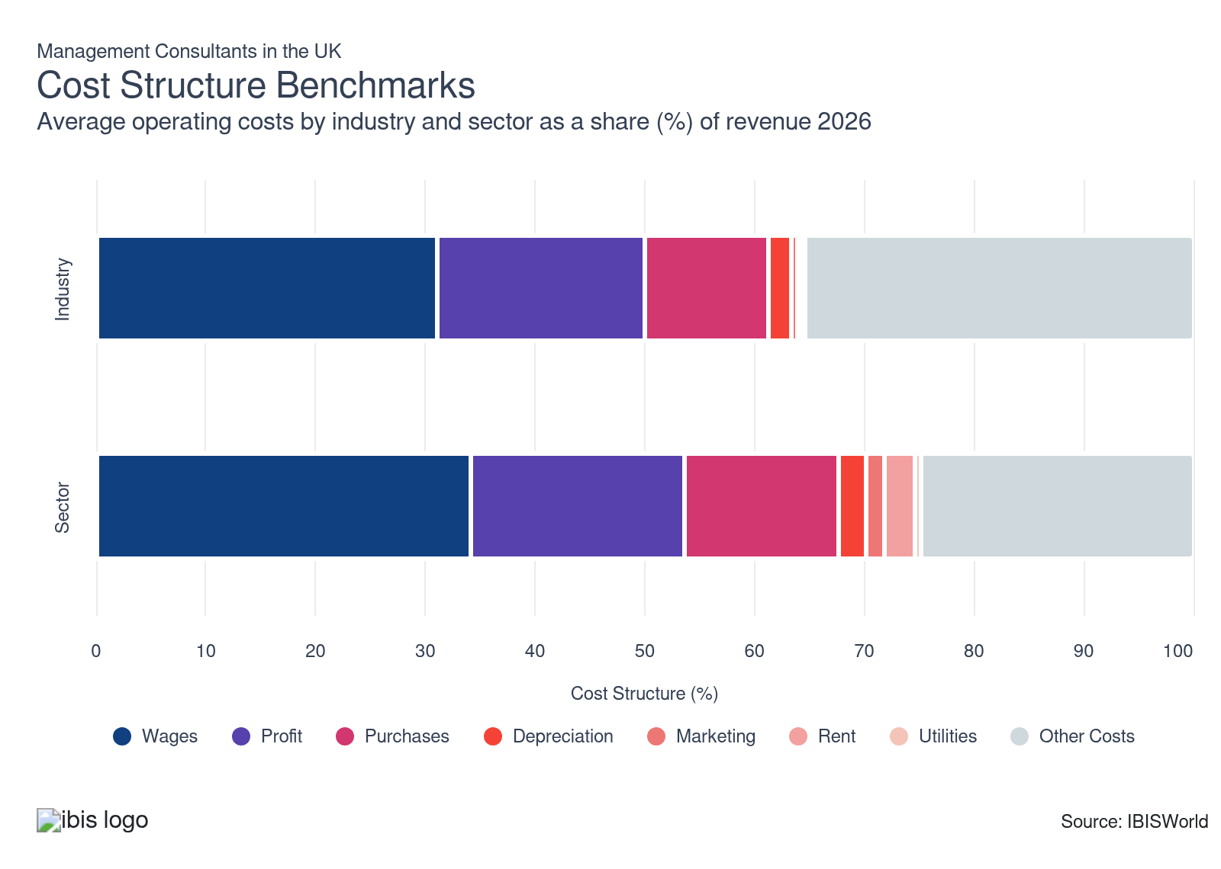
Chart displays current year only in the PDF version of this report. You can view and download chart for all other years associated with this industry on my.ibisworld.com.

What trends impact industry costs?

Profit varies depending on the service offered and the company's reputation
- Larger companies, like the Big Four accountancy firms, can achieve a higher profit margin, as they reap the benefits of economies of scale and vertical integration. Taxation and audit procedures enable these companies to bundle several products. Limited operating costs and the high value of consultancy work mean the industry enjoys a healthier profit margin than the wider Professional Services sector.
- Many small businesses have expanded their profit by offering their clients high-value and specialised niche consulting services, including environmental consulting and IT work like cybersecurity and cloud integration. Organisations are willing to fork out more to receive high-quality, tailored solutions in niche areas.
- Initiatives undertaken by several consultancies to enhance cost efficiencies have supported profitability. This has primarily involved reducing staff numbers amid economic uncertainty and a decline in consulting work. According to CityAM in December 2024, the Big Four firms made over 900 roles redundant in 2024. Nonetheless, intense competition for talent and inflationary pressures have raised wage cost.
- Some consultants have engaged in M&A activity to tap into promising consulting services like IT and sustainability, which has heightened restructuring costs, limiting profit expansion. Nonetheless, cost-cutting initiatives and a climb in demand for specialised services are supporting profit margin growth in 2025-26.

Wages rise owing to skilled labour shortages
- Wages represent the dominant cost for management consultancy firms, due to the reliance on highly-qualified staff.
- Wage costs have climbed over the past five years due to a shortage of skilled management consultants, requiring firms to raise wages to attract and retain talent. High inflation has also forced firms to hike staff wages. Strong demand for talent with skills in data, cybersecurity and cloud services is also hiking wage expenses as these workers command substantial pay packages.
- Several consultants, including the Big Four, have reduced permanent employee numbers to improve efficiencies and maintain profitability amid recent periods of heightened economic uncertainty and a slowdown in sales. For example, KPMG announced 200 job cuts in June 2024, while Deloitte revealed 800 layoffs in September 2023, followed by an extra 500 job cuts in 2024. Meanwhile, the Financial Times reports that the number of partner promotions at the Big Four accounting firms dropped to 179 in 2025, from over 200 in 2024 and from a peak of 276 in 2022, as they focus on protecting profit amid a slowdown in consulting demand.
- Consultants increasingly use freelancers and subcontractors, a trend encouraged by the need for staff to have more skills related to IT consulting. This has helped constrain wage cost growth. Investment in technology to automate some tasks and bring efficiencies has also eased wage cost pressures.

The need for high-quality information and general price inflation puts pressure on purchase costs
- Purchases include stationery, printing materials and subscription accounts for access to information that aids in decision-making. Management consultants also buy IT equipment and advanced software tools to meet client demand for digital transformation. Other purchases may include legal services incurred by tendering processes and contract drafting.
- Access to market research and reports can be pricey. As firms’ success is based on the performance of analysts and consultants, high-quality, reliable information is considered crucial as a decision-making tool.
- Recent inflationary pressures have raised the prices of goods and services, placing upward pressure on purchases. Although inflation is lower compared with the peaks reached in 2022-23, it has been creeping up in 2025-26 (at 3.6% in October 2025, as per ONS data), keeping purchase costs elevated in the current year.

Technological investment places upward pressure on depreciation costs
- Depreciation expenses relate to office equipment, IT equipment and company vehicles used by firms. These costs are low due to the labour-intensive nature of management consulting services.
- Depreciation costs have climbed slightly over the past five years as larger management consultancies have invested heavily in new technology to cope with an increasingly technology-focused world and enhance the value of their services.
- Investment in advanced tech tools like AI and data analytics is a main point of focus as consultants seek to enhance operational efficiencies and bring more value to clients, with the AI wave taking over more simple tasks while consultants deal with more complex work. Increasingly tech-savvy clients expect consultants to provide innovative tech solutions, placing an upward pressure on depreciation costs. According to The Financial Times in February 2025, the Management Consultancies Association has found that three-quarters of consulting firms plan to invest in AI, averaging £1.9 million over the next two years.

Marketing becomes more important as companies promote new consulting services
- Management consultants use marketing to differentiate themselves from competitors. Larger firms, including the Big Four and global consultancies like McKinsey and BCG, incur higher advertising costs to promote their services on a larger scale, while smaller firms operating locally tend to rely on recommendations and reputation.
- Consulting firms increasingly use digital marketing over traditional marketing methods as a cost-effective strategy to reach a wider audience through online channels. The intense level of competition for clients, efforts to boost brand visibility and promoting differentiated expertise have sustained marketing expenses over the past five years.

Rental costs are slim for consultancies that work from home or client sites
- As management consultants frequently travel to the client's site to conduct operations, workspace costs are low.
- Management consultants in the South East and London, particularly those located in the City of London, incur higher rent expenses due to the premium prices in these regions.
- An increasing number of companies have invested in technologies that enable consulting services to be performed virtually, a trend accelerated by the forced closure of offices during the pandemic. This has lessened the need for space to host clients, limiting rent costs. However, many clients still prefer consultants to come on-site, as human relationships remain vital.
- The shift to remote working has reduced the need for large office space, with some consultancies consolidating central offices, hindering rent costs. However, in recent years, more consultancies, particularly the larger ones, have been investing in standout offices to incentivise staff to return and to attract talent, keeping rent costs steady over the past five years.

Utility costs aren’t a big consideration for management consultants
- Utility costs are related to the general operation of office buildings, including the price of electricity and heating. The service-based nature of the industry means that utility costs account for a very small share of revenue. Further, consultants are frequently working on projects at clients’ sites, limiting energy use.
- The energy crisis raised electricity prices in 2022-23. However, sustainability initiatives and a push for more renewable energy use helped limit utility costs. For example, PwC UK has transitioned 100% of its offices to renewable electricity, while KPMG also uses 100% renewable energy across its estate. Other firms are also making progress on this front. This has kept the share of revenue absorbed by utilities fairly steady over the past five years.

Consultancy firms seek subcontracted labour to lower fixed costs
- Other costs for consultancy firms include general overheads, transportation expenses, insurance, taxes and accounting fees.
- Sizeable payments to subcontractors mean that consulting firms spend a higher share of revenue on other costs than the wider sector. Depending on the work, it’s often more efficient to outsource labour on a project-by-project basis. Subcontracted labour also increases flexibility and reduces fixed costs. Firms have turned to skilled subcontractors to provide valuable services in niche segments like digital transformation.
- Since consultants serve a variety of industries, a significant portion of revenue is allocated toward compliance, ensuring recommended projects or investments fall within the guidelines of relevant regulations.
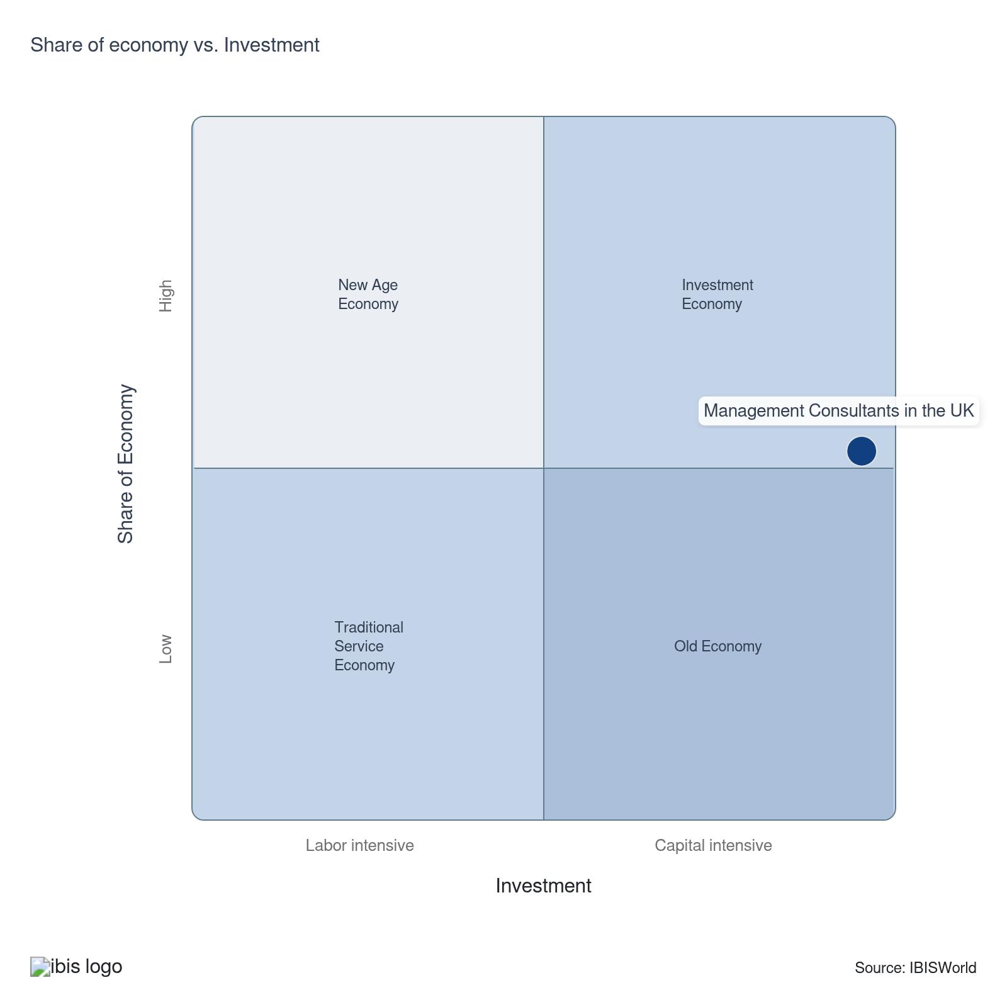

Financial Ratios

Liquidity Ratios
Ratio | Apr 21-Mar 22 | Apr 22-Mar 23 | Apr 23-Mar 24 | Apr 24-Mar 25 | Small  (<£10.2m) | Medium  (£10.2m-£36m) | Large  (>£36m)
Current Ratio | 35.0 | 102.3 | 51.9 | 10.2 | 113.4 | 1.3 | N/A
Day’s Payables | 468.1 | 110.1 | 206.1 | 950.5 | N/A | N/A | N/A
Days’ Inventory | 58.4 | 1301.4 | 256.2 | 12.8 | N/A | N/A | N/A
Days’ Receivables | 120.2 | 254.8 | 119.9 | 91.8 | 91.8 | N/A | N/A
Inventory Turnover | 22517.9 | 23001.5 | 19681.6 | 2241.6 | 2241.6 | N/A | N/A
Payables Turnover | 212.0 | 352.1 | 521.8 | 47.0 | 69.1 | 19.0 | N/A
Quick ratio (Acid test) | 2.0 | 6.5 | 7.1 | N/A | N/A | N/A | N/A
Trade Receivables Turnover | 43.2 | 94.2 | 187.4 | 7.5 | 7.5 | N/A | N/A
Working Capital Turnover | 246.5 | 248.6 | 298.7 | 645.3 | N/A | N/A | N/A

Coverage Ratios
Ratio | Apr 21-Mar 22 | Apr 22-Mar 23 | Apr 23-Mar 24 | Apr 24-Mar 25 | Small  (<£10.2m) | Medium  (£10.2m-£36m) | Large  (>£36m)
Cash Flow Coverage Ratio | -0.9 | -0.2 | -5.0 | N/A | N/A | N/A | N/A
Cash Flow Margin Ratio | N/A | 0.1 | 0.2 | -0.5 | -0.7 | N/A | N/A
Current Liability Coverage Ratio | 1.1 | -0.3 | -0.3 | -1.4 | -1.3 | -0.4 | N/A
Interest Coverage | 8562.2 | 14426.6 | 702.3 | -267.5 | -690.1 | 14.3 | N/A

Leverage Ratios
Ratio | Apr 21-Mar 22 | Apr 22-Mar 23 | Apr 23-Mar 24 | Apr 24-Mar 25 | Small  (<£10.2m) | Medium  (£10.2m-£36m) | Large  (>£36m)
Fixed Assets / Tangible Net Worth | 20671.6 | 19846.5 | 16411.6 | 19.3 | 1.4 | 0.6 | N/A
Net Worth Ratio | N/A | 49.7 | N/A | N/A | 178.1 | 43.2 | N/A
Tangible debt / Tangible Net worth | 250.7 | 594.7 | 447.7 | 248.7 | -0.5 | N/A | N/A
Tangible Net Worth | 87981.0 | 164100.1 | 104107.6 | 117828.8 | 1.4 | 0.6 | N/A
Total Debt / Net EBITDA | 36.6 | 67.6 | 23.8 | -11.4 | -17.9 | N/A | N/A
Total Debt / Tangible Net Worth | 250.7 | 594.7 | 447.7 | 248.7 | -0.5 | N/A | N/A

Operating Ratios
Ratio | Apr 21-Mar 22 | Apr 22-Mar 23 | Apr 23-Mar 24 | Apr 24-Mar 25 | Small  (<£10.2m) | Medium  (£10.2m-£36m) | Large  (>£36m)
Asset Turnover | 104.5 | 187.1 | 130.6 | 177.1 | 187.9 | -5.8 | N/A
Fixed Asset Turnover | 11613.8 | 6634.5 | 899.9 | 93.9 | N/A | N/A | N/A
Gross Profit / Turnover | 0.7 | 0.5 | 0.5 | 0.7 | 0.7 | 0.4 | N/A
Net Profit / Turnover | 2.0 | 0.2 | -0.8 | -0.9 | -1.0 | N/A | N/A
Return on total Assets (ROTA) | 31.8 | 49.0 | 1361.5 | 0.7 | 1.0 | -0.3 | N/A

Assets, %
Ratio | Apr 21-Mar 22 | Apr 22-Mar 23 | Apr 23-Mar 24 | Apr 24-Mar 25 | Small  (<£10.2m) | Medium  (£10.2m-£36m) | Large  (>£36m)
Cash & Equivalents | 0.2 | 0.2 | 0.3 | 0.6 | 3.3 | -0.3 | N/A
Fixed Assets | 0.1 | 0.2 | 0.2 | 0.2 | N/A | N/A | N/A
Inventory | N/A | 1.7 | 0.4 | 0.2 | 0.1 | N/A | N/A
Total Assets | 1.0 | 1.0 | 1.0 | 1.0 | 1.0 | 1.0 | N/A
Total Assets (£m) | 120,780.9 | 211,663.5 | 142,150.7 | 152,109.9 | N/A | N/A | N/A
Total Current Assets | 0.6 | 0.4 | 0.9 | 0.8 | 1.5 | -0.9 | N/A
Trade Receivables (net) | 3.8 | 0.2 | -0.7 | N/A | 0.3 | N/A | N/A

Liabilities, %
Ratio | Apr 21-Mar 22 | Apr 22-Mar 23 | Apr 23-Mar 24 | Apr 24-Mar 25 | Small  (<£10.2m) | Medium  (£10.2m-£36m) | Large  (>£36m)
Long Term Debt | 6.4 | 1.6 | 4.1 | -1.2 | 20.9 | N/A | N/A
Net Worth | -32.3 | -17.5 | -17.9 | -1.4 | 1.4 | 0.6 | N/A
Short Term Debt | -34.5 | -12.4 | -10.1 | 4.1 | 1.9 | -0.8 | N/A
Total Current Liabilities | 0.1 | 0.1 | 0.2 | N/A | N/A | N/A | N/A
Total Liabilities & Net Worth (£m) | 120,780.9 | 211,663.5 | 142,150.7 | 152,109.9 | N/A | N/A | N/A
Trade Payables | 5.2 | N/A | 0.1 | N/A | 1.5 | -0.4 | N/A

Valuation Multiples

Valuation Multiples
Ratio | Apr 20-Mar 21 | Apr 21-Mar 22 | Apr 22-Mar 23 | Apr 23-Mar 24 | 3 Year Average | 5 Year Average
EV/Revenue | 0.2 | 0.3 | 0.3 | 0.2 | 0.3 | 0.2
EV/EBITDA | 1.1 | 1.4 | 1.3 | 1.3 | 1.3 | 1.2
EV/EBIT | 1.1 | 1.4 | 1.3 | 1.3 | 1.3 | 1.2

Key Ratios
Year | Revenue per Employee  (£) | Revenue per Enterprise  (£ Million) | Employees per Estab.  (Units) | Employees per Enterprise  (Units) | Average Wage  (£) | Wages/ Revenue  (%) | Estab. per Enterprise  (Units) | IVA/ Revenue  (%)
2012-13 | 156,228 | 0.5 | 2.9 | 3.0 | 47,325 | 30.3 | 1.0 | 51.8
2013-14 | 161,917 | 0.5 | 2.9 | 2.9 | 46,265 | 28.6 | 1.0 | 54.0
2014-15 | 175,237 | 0.5 | 2.8 | 2.8 | 48,647 | 27.8 | 1.0 | 54.5
2015-16 | 162,146 | 0.4 | 2.7 | 2.7 | 49,862 | 30.8 | 1.0 | 52.8
2016-17 | 159,602 | 0.4 | 2.5 | 2.5 | 53,721 | 33.7 | 1.0 | 53.0
2017-18 | 185,679 | 0.5 | 2.5 | 2.6 | 56,004 | 30.2 | 1.0 | 53.0
2018-19 | 196,677 | 0.5 | 2.6 | 2.6 | 52,346 | 26.6 | 1.0 | 49.6
2019-20 | 194,883 | 0.5 | 2.4 | 2.6 | 52,748 | 27.1 | 1.1 | 49.8
2020-21 | 177,311 | 0.5 | 2.4 | 2.7 | 51,002 | 28.8 | 1.1 | 48.4
2021-22 | 184,981 | 0.5 | 2.4 | 2.6 | 56,256 | 30.4 | 1.1 | 49.0
2022-23 | 185,689 | 0.5 | 2.4 | 2.6 | 57,584 | 31.0 | 1.1 | 51.6
2023-24 | 179,323 | 0.5 | 2.4 | 2.6 | 56,144 | 31.3 | 1.1 | 51.6
2024-25 | 175,718 | 0.5 | 2.4 | 2.6 | 54,775 | 31.2 | 1.1 | 51.8
2025-26 | 172,496 | 0.4 | 2.4 | 2.6 | 53,610 | 31.1 | 1.1 | 52.1
2026-27 | 174,673 | 0.4 | 2.4 | 2.6 | 54,016 | 30.9 | 1.1 | 52.5
2027-28 | 178,352 | 0.5 | 2.3 | 2.6 | 54,698 | 30.7 | 1.1 | 52.6
2028-29 | 180,641 | 0.5 | 2.3 | 2.5 | 55,120 | 30.5 | 1.1 | 52.6
2029-30 | 182,411 | 0.5 | 2.3 | 2.5 | 55,444 | 30.4 | 1.1 | 52.6
2030-31 | 183,552 | 0.5 | 2.3 | 2.5 | 55,652 | 30.3 | 1.1 | 52.7
2031-32 | 183,448 | 0.5 | 2.3 | 2.5 | 55,633 | 30.3 | 1.1 | 52.9
*Figures are inflation adjusted to 2025
*Figures are inflation adjusted to 2025

10. Key Statistics
https://my.ibisworld.com/uk/en/industry/M70.229/key-statistics

Industry Data

Values
Year | Revenue  (£ Million) | IVA  (£ Million) | Estab.  (Units) | Enterprises  (Units) | Employment  (Units) | Wages  (£ Million)
2012-13 | 54,269.0 | 28,096.3 | 119,280 | 116,155 | 347,370 | 16,439.2
2013-14 | 60,091.2 | 32,458.5 | 129,483 | 127,134 | 371,124 | 17,170.1
2014-15 | 67,473.3 | 36,788.9 | 138,972 | 137,659 | 385,040 | 18,731.1
2015-16 | 66,882.8 | 35,324.8 | 154,531 | 152,263 | 412,485 | 20,567.3
2016-17 | 65,303.6 | 34,636.3 | 164,900 | 162,911 | 409,166 | 21,980.6
2017-18 | 77,238.9 | 40,901.2 | 165,513 | 161,347 | 415,981 | 23,296.7
2018-19 | 83,988.1 | 41,619.5 | 165,929 | 161,887 | 427,035 | 22,353.6
2019-20 | 81,154.1 | 40,400.1 | 172,735 | 158,622 | 416,425 | 21,965.8
2020-21 | 74,444.0 | 36,062.2 | 172,912 | 158,418 | 419,850 | 21,413.2
2021-22 | 79,347.4 | 38,858.7 | 178,667 | 164,519 | 428,948 | 24,131.0
2022-23 | 83,612.1 | 43,155.8 | 186,124 | 171,865 | 450,281 | 25,928.9
2023-24 | 82,788.2 | 42,697.6 | 191,119 | 176,488 | 461,671 | 25,920.1
2024-25 | 82,247.0 | 42,565.2 | 195,736 | 180,351 | 468,064 | 25,638.4
2025-26 | 82,029.9 | 42,730.9 | 200,505 | 184,136 | 475,546 | 25,494.0
2026-27 | 85,272.4 | 44,726.4 | 206,955 | 190,378 | 488,182 | 26,369.6
2027-28 | 90,168.2 | 47,408.4 | 215,596 | 198,123 | 505,564 | 27,653.5
2028-29 | 94,003.9 | 49,442.3 | 222,866 | 204,694 | 520,391 | 28,683.7
2029-30 | 97,656.7 | 51,403.8 | 230,048 | 211,569 | 535,367 | 29,682.7
2030-31 | 101,207.6 | 53,350.6 | 237,285 | 218,600 | 551,383 | 30,685.4
2031-32 | 104,119.3 | 55,063.2 | 243,898 | 224,552 | 567,567 | 31,575.4

*Figures are inflation adjusted to 2025

Annual Change
Year | Revenue  % | IVA  % | Estab.  % | Enterprises  % | Employment  % | Wages  %
2012-13 | N/A | N/A | N/A | N/A | N/A | N/A
2013-14 | 10.7 | 15.5 | 8.6 | 9.5 | 6.8 | 4.4
2014-15 | 12.3 | 13.3 | 7.3 | 8.3 | 3.7 | 9.1
2015-16 | -0.9 | -4.0 | 11.2 | 10.6 | 7.1 | 9.8
2016-17 | -2.4 | -1.9 | 6.7 | 7.0 | -0.8 | 6.9
2017-18 | 18.3 | 18.1 | 0.4 | -1.0 | 1.7 | 6.0
2018-19 | 8.7 | 1.8 | 0.3 | 0.3 | 2.7 | -4.0
2019-20 | -3.4 | -2.9 | 4.1 | -2.0 | -2.5 | -1.7
2020-21 | -8.3 | -10.7 | 0.1 | -0.1 | 0.8 | -2.5
2021-22 | 6.6 | 7.8 | 3.3 | 3.9 | 2.2 | 12.7
2022-23 | 5.4 | 11.1 | 4.2 | 4.5 | 5.0 | 7.5
2023-24 | -1.0 | -1.1 | 2.7 | 2.7 | 2.5 | 0.0
2024-25 | -0.7 | -0.3 | 2.4 | 2.2 | 1.4 | -1.1
2025-26 | -0.3 | 0.4 | 2.4 | 2.1 | 1.6 | -0.6
2026-27 | 4.0 | 4.7 | 3.2 | 3.4 | 2.7 | 3.4
2027-28 | 5.7 | 6.0 | 4.2 | 4.1 | 3.6 | 4.9
2028-29 | 4.3 | 4.3 | 3.4 | 3.3 | 2.9 | 3.7
2029-30 | 3.9 | 4.0 | 3.2 | 3.4 | 2.9 | 3.5
2030-31 | 3.6 | 3.8 | 3.1 | 3.3 | 3.0 | 3.4
2031-32 | 2.9 | 3.2 | 2.8 | 2.7 | 2.9 | 2.9

*Figures are inflation adjusted to 2025

DISCLAIMER
This product has been supplied by IBISWorld Ltd. (‘IBISWorld’) solely for use by its authorised licensees strictly in accordance with their licence agreements with IBISWorld. IBISWorld makes no representation to any other person with regard to the completeness or accuracy of the data or information contained herein, and it accepts no responsibility and disclaims all liability (save for liability that cannot be lawfully disclaimed) for loss or damage whatsoever suffered or incurred by any other person resulting from the use of, or reliance upon, the data or information contained herein. Copyright in this publication is owned by IBISWorld Ltd. The publication is sold on the basis that the purchaser agrees not to copy the material contained within it for other than the purchaser’s own purposes. In the event that the purchaser uses or quotes from the material in this publication – in papers, reports or opinions prepared for any other person – it is agreed that it will be sourced to IBISWorld Ltd

